RSA28E
485 bus type open and closed loop stepper driver

User Manual V1.0.1

Shenzhen GRMOT Technology Co., Ltd.
Table of contents
one,Product Introduction - 1 -
1.1 Product Overview - 1 -
1.2 Product Features - 1 -
1.3 Application Areas - 2 -
two,Mechanical, electrical and environmental specifications - 2 -
2.1 Mechanical Installation Drawing - 2 -
2.2 Installation Notes - 3 -
2.3 Electrical specifications - 4 -
2.4 Operating environment and parameters - 4 -
3. Driver interface and wiring description - 5 -
3.1 Product Silk Screen - 5 -
3.2 DIP switch - 5 -
3.2.1 Driver address setting - 5 -
3.2.2 Communication baud rate setting - 7 -
3.2.3 Open-loop and closed-loop mode settings - 7 -
3.2.4 Current setting - 7 -
3.2.5 Terminal resistance setting - 8 -
3.3 Indicator Lights - 8 -
3.4 RS485 communication interface - 8 -
3.5 Input Signal Interface - 9 -
3.5.1 Input signal description and wiring diagram - 9 -
3.5.2 Input signal interface function - 10 -
3.5.3 Input Signal Interface Function Description - 11 -
3.6 Output signal interface - 13 -
3.6.1 Output signal description and wiring diagram - 13 -
3.6.2 Output signal interface function - 14 -
3.6.3 Output signal interface function description - 14 -
3.6.4 Brake Motor Brake Wiring Diagram - 15 -
3.7 Encoder input signal interface - 17 -
3.8 Motor Control Output Interface - 17 -
3.9 Power Input Interface - 17 -
4. MODBUS communication protocol and functions - 17 -
4.1 Basic communication parameters - 17 -
4.2 MODBUS register address definition - 18 -
4.2.1 Status parameter group (read-only) - 18 -
4.2.2 Public parameter group 1 (read and write) - 23 -
4.2.3 Common parameters in open loop mode (read and write) - 26 -
4.2.4 Common parameter group in closed loop mode (read and write) - 27 -
4.2.5 Driver basic control parameter group 1 (read and write) - 30 -
4.2.6 Return to origin parameter group (read and write) - 32 -
4.2.7 Driver Basic Control Parameter Group 2 (Read and Write) - 34 -
4.2.8 Public Parameter Group 2 (Read and Write) - 35 -
4.2.9 Input and output function parameter group (read and write) - 36 -
4.2.10 Multi-segment mode parameter group (read and write) - 40 -
4.2.11 Performance parameter group (read and write) - 45 -
4.2.12 Brake Control Parameter Group (Read and Write) - 51 -
4.2.13 Status and fault code parameter group (read only) - 52 -
4.2.14 User parameter group (read and write) - 56 -
4.3 Common MODBUS function codes - 57 -
4.3.1 Read Holding Register Command 0x03 - 57 -
4.3.2 Write Single Register Command 0x06 - 58 -
4.3.3 Write multiple registers command 0x10 - 58 -
4.4 Communication Error Codes - 59 -
4.4.1 CRC Check Error - 59 -
4.4.2 Function code sending error - 60 -
4.4.3 Reading illegal data address error - 60 -
4.4.4 The address of written data exceeds the address range - 60 -
4.4.5 Read register count overflow - 61 -
4.4.6 Illegal read and write data error of function code - 61 -
4.4.7 Data written into register exceeds limit - 61 -
4.5 Application Examples - 62 -
4.5.1 Position Mode Operation Setting Example - 62 -
4.5.2 Speed ​​Mode Operation Setting Example - 63 -
5. Introduction to Motion Control Function - 65 -
5.1 Position Mode - 65 -
5.2 Speed ​​Mode - 66 -
5.3 Return to origin mode - 67 -
5.3.1 Mode (-3) (Stalled Rotor Return to Zero 1) - 68 -
5.3.2 Mode (-4) (Stalled Rotor Return to Zero 2) - 68 -
5.3.3 Mode (-5) (Stalled Rotor Return to Zero 3) - 69 -
5.3.4 Mode (-6) (Stalled Rotor Return to Zero 4) - 69 -
5.3.5 Mode 17 (Negative Limit Return to Zero) - 70 -
5.3.6 Mode 18 (Positive limit return to zero) - 70 -
5.3.7 Mode 19 (Home Return 1) - 71 -
5.3.8 Mode 20 (Home Return 2) - 71 -
5.3.9 Method 21 (Home Return 3) - 72 -
5.3.10 Mode 22 (Home Return 4) - 72 -
5.3.11 Mode 23 (origin + positive limit return to zero 1) - 73 -
5.3.12 Mode 24 (origin + positive limit return to zero 2) - 74 -
5.3.13 Mode 25 (origin + positive limit return to zero 3) - 74 -
5.3.14 Mode 26 (origin + positive limit return to zero 4) - 76 -
5.3.15 Mode 27 (origin + negative limit return to zero 1) - 76 -
5.3.16 Mode 28 (origin + negative limit return to zero 2) - 77 -
5.3.17 Mode 29 (origin + negative limit return to zero 3) - 77 -
5.3.18 Mode 30 (origin + negative limit return to zero 4) - 78 -
5.3.19 Mode 33 (Z signal return to zero 1) - 78 -
5.3.20 Mode 34 (Z signal return to zero 2) - 79 -
5.3.21 Methods 35 and 37 (Current Position as Origin) - 79 -
5.3.22 Mode 38 (Position return to zero mode 1) - 79 -
5.3.23 Mode 39 (Position return to zero mode 2) - 80 -
5.3.24 Mode 41 (Dual Photoelectric Zero Return 1: Origin + Positive Limit) - 80 -
5.3.25 Mode 42 (Dual Photoelectric Zero Return 2: Origin + Positive Limit) - 80 -
5.3.26 Mode 43 (Dual Photoelectric Zero Return 3: Origin + Positive Limit) - 81 -
5.3.27 Mode 44 (Dual Photoelectric Zero Return 4: Origin + Positive Limit) - 81 -
5.3.28 Mode 45 (Dual Photoelectric Zero Return 5: Origin + Negative Limit) - 82 -
5.3.29 Mode 46 (Dual Photoelectric Zero Return 6: Origin + Negative Limit) - 82 -
5.3.30 Mode 47 (Dual Photoelectric Zero Return 7: Origin + Negative Limit) - 83 -
5.3.31 Mode 48 (Dual Photoelectric Zero Return 8: Origin + Negative Limit) - 83 -
5.4 Multi-segment mode - 84 -
5.4.1 Multi-position mode - 84 -
5.4.1.1 IO Trigger + Path IO Mode - 85 -
5.4.1.2 IO trigger single cycle mode - 87 -
5.4.1.3 IO trigger continuous loop mode - 88 -
5.4.2 Multi-speed mode - 88 -
5.5 Motion Control Instructions - 90 -
5.5.1 Startup Command - 90 -
5.5.2 Stop Command - 90 -
6. Indicator Light - 92 -
6.1 Alarm fault codes - 92 -
6.2 Indicator light flashes - 95 -
7. Warranty and after-sales - 97 -
7.1 Warranty - 97 -
7.1.1 Free warranty - 97 -
7.1.2 Warranty Exclusion - 97 -
7.2 Exchange - 97 -
7.2.1 Product Replacement for Faulty Products - 97 -
7.2.2 Exchange for non-product failure - 98 -
7.3 Returns - 98 -
7.4 After-sales Service - 99 -
8. Version Revision History - 99 -

Product Introduction

1.1 Product Overview
The 485 bus open-closed loop stepper driver is the latest digital hybrid stepper servo driver with serial port debugging function launched by Shenzhen Ge Rui Wu Lian Technology Co., Ltd. It integrates the MODBUS-RTU standard protocol specification and uses a standard RJ45 interface for the communication network port. Users can set various parameters such as subdivision, current, speed, and working mode through the host computer debugging software, which greatly enriches the practical functions of the product and can meet the application needs of most occasions.
The 485 bus-based open- and closed-loop stepper driver utilizes a servo-like control principle, combining the advantages of both open-loop stepper and servo systems. It employs the latest 32-bit DSP control technology, significantly improving stepper system performance. It offers excellent stability and ultra-low noise at both medium and low speeds, while significantly increasing high-speed torque, expanding the speed range of stepper motors. Smooth, precise pure sinusoidal current vector control effectively reduces motor heating, and its high compatibility and cost-effectiveness make it suitable for most applications.

1.2 Product Features
●New generation 32-bit DSP technology, good stability, strong compatibility and high cost performance
●Support open-loop and closed-loop mode switching
●Support speed mode, position mode, multi-position mode and homing mode
● Current, lock current, subdivision, PI and other parameters can be set and queried through the master station
●Use RS485 bus with isolation and support standard MODBUS-RTU protocol
●Dip code SW1-5 sets the driver communication address, which can support 31 devices, and more can be set through the master station
11-channel optoelectronically isolated programmable input interface, receiving external control signals to realize drive enable, start/stop, limit and other functions
5-way opto-isolated programmable output interface, output driver status and control signals, such as alarm, arrival, return to origin completion, etc.
●Built-in micro-segmentation, excellent low-speed stability
●With overcurrent, overvoltage, undervoltage, phase loss, out-of-tolerance and other protection functions
●Pure sinusoidal current vector control effectively reduces motor heating
●AC/DC universal, voltage range: AC20~50V/DC24V~70V

1.3 Application Areas
Suitable for various small and medium-sized automation equipment and instruments, such as engraving machines, marking machines, cutting machines, plotters, CNC machine tools, automatic assembly equipment, etc. It works particularly well in equipment applications where users expect low noise and high speed.

Mechanical, electrical and environmental specifications

2.1 Mechanical Installation Drawing
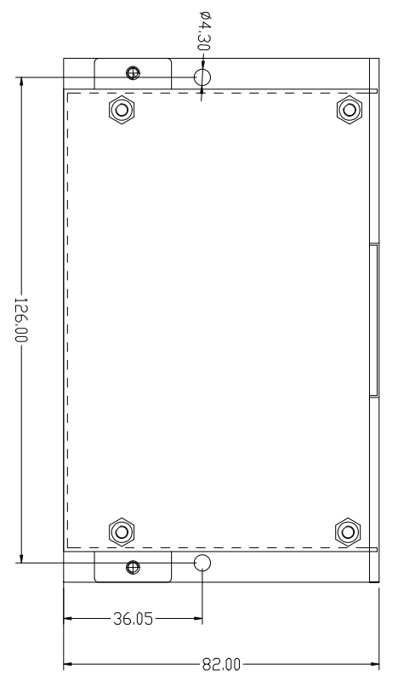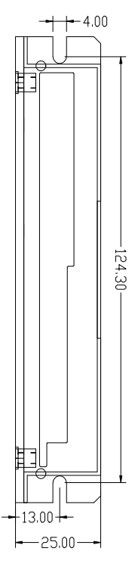
Front installation diagram Side installation diagram
Figure 1 Installation dimensions (unit: mm)

2.2 Installation Notes
- When installing the driver, please install it sideways for better heat dissipation. When designing the installation dimensions, consider the terminal size and wiring.
- In order to ensure good heat dissipation conditions, a larger installation interval must be reserved as much as possible during actual installation.If necessary, install a fan near the driver inside the machine to create strong air convection on the bottom of the driver to assist in heat dissipation and ensure that the driver operates within a reliable operating temperature range.

2.3 Electrical specifications
illustrate | 485 bus type open and closed loop driver
illustrate | Minimum | Typical values | Maximum | unit
Output current | 0 | - | 6000 | mA
Input power voltage | 20 | - | 50 | VAC
Input power voltage | twenty four | 36 | 70 | VDC
Control signal input current | 7 | 10 | 16 | mA
Insulation resistance | 50 | - | - | MΩ

2.4 Operating environment and parameters
Cooling method |  | Natural cooling, fan cooling
Usage Environment | occasion | Do not place it near other heating equipment. Avoid dust, oil mist, corrosive gas, high humidity and strong vibration. Flammable gas and conductive dust are prohibited.
Usage Environment | temperature | -25℃~55℃
Usage Environment | humidity | 40~90%RH
Usage Environment | vibration | 10~55Hz/0.15mm
Storage temperature |  | -25℃~65℃

3. Driver interface and wiring description

3.1 Product Silk Screen
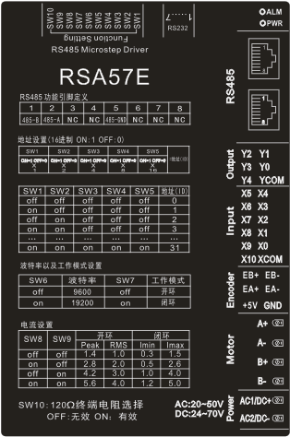

3.2 DIP switch
Table 3.1 DIP switch function description
name | Function | illustrate
Dip switch SW1-SW10 | Set address, baud rate, open/closed loop mode, current, and terminal resistance selection | SW1-SW5: Drive address setting
Dip switch SW1-SW10 |  | SW6: Baud rate setting
Dip switch SW1-SW10 |  | SW7: Open and closed loop mode setting
Dip switch SW1-SW10 |  | SW8-SW9: Open and closed loop current setting
Dip switch SW1-SW10 |  | SW10: 120 terminal resistance valid bit

3.2.1 Driver address setting
The host computer uses RS485 bus communication and can control up to 31 485 drives using the DIP switches. The drive communication address is set via the SW1-SW5 DIP switches, with an address range of 1-31, as shown in Table 3.2. When the drive address is set to greater than 31, the host computer must send a change address command to set it. However, before setting, all SW1-SW5 DIP switches must be set to off. After the setting is completed and saved, it must be powered on again for it to take effect.
Note: Make sure the communication address of each driver is unique, otherwise it will cause communication conflicts!

Table 3.2 Driver address settings
SW1 | SW2 | SW3 | SW4 | SW5 | =Address(ID)
on=1 off=0  ×  1 | on=1 off=0  ×  2 | on=1 off=0  ×  4 | on=1 off=0  ×  8 | on=1 off=0  ×  16 | =Address(ID)
off | off | off | off | off | 1 (customizable)
on | off | off | off | off | 1
off | on | off | off | off | 2
on | on | off | off | off | 3
off | off | on | off | off | 4
on | off | on | off | off | 5
off | on | on | off | off | 6
on | on | on | off | off | 7
off | off | off | on | off | 8
on | off | off | on | off | 9
off | on | off | on | off | 10
on | on | off | on | off | 11
off | off | on | on | off | 12
on | off | on | on | off | 13
off | on | on | on | off | 14
on | on | on | on | off | 15
off | off | off | off | on | 16
on | off | off | off | on | 17
off | on | off | off | on | 18
on | on | off | off | on | 19
off | off | on | off | on | 20
on | off | on | off | on | twenty one
off | on | on | off | on | twenty two
on | on | on | off | on | twenty three
off | off | off | on | on | twenty four
on | off | off | on | on | 25
off | on | off | on | on | 26
on | on | off | on | on | 27
off | off | on | on | on | 28
on | off | on | on | on | 29
off | on | on | on | on | 30
on | on | on | on | on | 31

3.2.2 Communication baud rate setting
The communication baud rate can be set via SW6, as shown in Table 3.3 below. If the communication baud rate in the table does not meet the requirements, the communication baud rate can be customized via the host computer. The prerequisite is that SW6 must be turned to the off state. See the description of register 0x0015 for details.
Table 3.3 Communication baud rate settings
SW6 | Baud rate
off | 9600 (customizable)
on | 19200

3.2.3 Open-loop and closed-loop mode settings
The open-loop and closed-loop modes can be selected by dialing SW7, as shown in the table below. Open-loop and closed-loop modes can also be selected through the host computer software, provided that SW7 is turned off. For details, see the description of register 0x001C.
Table 3.4 Open-loop and closed-loop mode settings
SW7 | Working Mode
off | Open loop (customizable)
on | closed loop

3.2.4 Current setting
In both open and closed loop modes, the current can be set by dialing SW8-SW9. There are 4 current options. The full off state corresponds to the minimum current, and the full on state corresponds to the maximum current.28-42If the user needs to adjust the current, it can be set through the host computer software, butYou need to turn SW8-SW9 to the off position to make adjustments.
Table 3.5 Current setting
SW8 | SW9 | Open loop |  | closed loop
SW8 | SW9 | Peak(A) | RMS(A) | Imin(A) | Imax(A)
off | off | 0.6 | 0.4 | 0.2 | 0.7
on | off | 0.8 | 0.6 | 0.3 | 1.0
off | on | 1.1 | 0.8 | 0.4 | 1.5
on | on | 1.4 | 1.0 | 0.5 | 2.0

3.2.5 Terminal resistance setting
The user can use DIP switch SW10 to select whether to incorporate a 120Ω terminal resistor into the communication terminal. This is determined based on the application scenario. The settings are shown in Table 3.6 below.
Table 3.6 120Ω terminal resistor selection
SW10 | 120Ω terminal resistor
off | invalid
on | efficient

3.3 Indicator Lights
The indicator light of the 485 bus type open and closed loop stepper driver is a retracted SMD LED. There is a small cutout on the driver to observe the indicator light status. Its basic functions are shown in Table 3.7 below.
Table 3.7 Definition of indicator lights
name | describe | Function | illustrate
ALM | Red LED | Power supply, save parameter function indicator, restore factory settings function indicator, dial status switch indicator,  Alarm indicator light | When the power is on normally, the green light is always on and the red light is off.  When saving parameters, restoring factory settings, switching the dial status, or when the device is abnormal, the red and green lights will flash alternately to give an alarm. For the flashing pattern, please refer to Chapter 6.
PWR | Green LED

3.4 RS485 communication interface
The communication interface of the 485 bus open- and closed-loop stepper driver uses a one-piece standard RJ45 socket. As shown in Figure 3.2 below, the RJ45 interface has 8 pins, of which pins 1 and 2 are used for RS485 half-duplex communication, pin 5 is the RS485 common ground terminal, and the other pins are unused, as shown in Table 3.8 below.
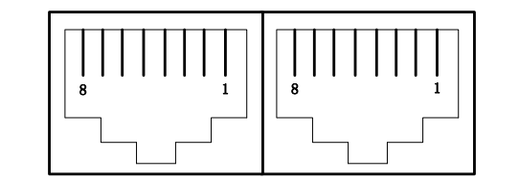

Figure 3.2 Schematic diagram of one-piece RJ45 interface
Table 3.8 RJ45 pin function distribution
Pins | definition
1 | RS485-B
2 | RS485-A
3 | NC
4 | NC
5 | RS485-GND
6 | NC
7 | NC
8 | NC

3.5 Input Signal Interface

3.5.1 Input signal description and wiring diagram
485 bus type open and closed loop stepper driver provides a programmable interface with optical isolation input.
The input interface adopts common anode connection and is connected to +24V externally. To ensure reliable conduction of the optocoupler inside the driver, the driving current on the controller side is required to be at least 10mA, and the input level pulse width needs to be greater than 10ms, otherwise the driver may not respond normally. The wiring diagram is shown in Figure 3.3.
After the driver is powered on normally, the effective level of the input interface is initially defaulted to the rising edge or high level.The user can also configure the effective level of the input interface to be initially set to falling edge or low level by default through the master station.
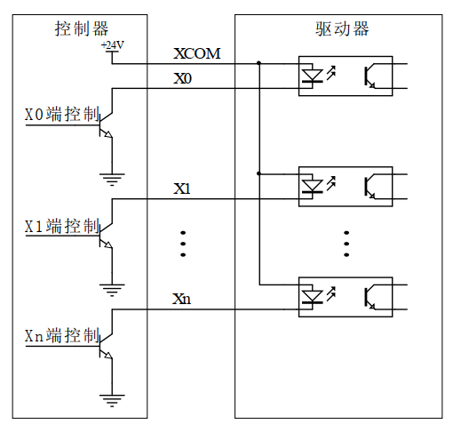
Figure 3.3 Input signal wiring diagram
Note: The default input interface of the 485 bus type open-closed loop stepper driver supports 24V signal. If the user requires 5V signal control, it is necessary to communicate with our sales or technical personnel to make changes.
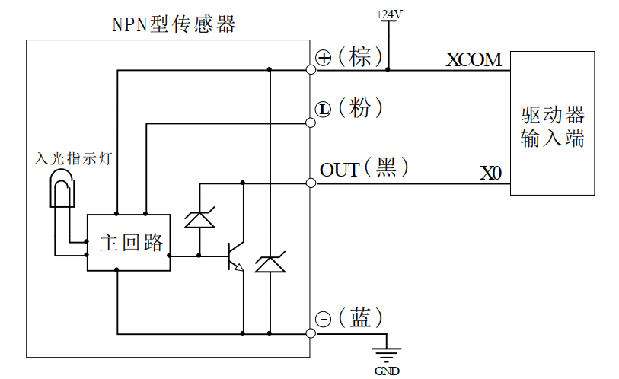
If the input port is connected to a sensor, only NPN sensor wiring is supported. Taking the X0 input port as an example, the wiring diagram is as follows:

Figure 3.4 NPN sensor wiring diagram

3.5.2 Input signal interface function
The 485 bus type open and closed loop stepper driver has a variety of configurable functions on its input ports. Users can set the corresponding input IO port functions through the host computer. Each input IO port can be set to up to 21 functions, as shown in Table 3.9 below.
Table 3.9 Input interface function definition
name |  | illustrate | Functional Description
Input | X0 | Low-speed digital signal  Input interface | 0: undefined;  1: Origin signal;  2: Positive limit signal;  3: Negative limit signal;  4: Motor MF enable/release signal;  5: Brake control input signal;  6: Alarm clear signal;  7: Function code restores factory settings signal;  8: Normal stop signal;  9: Emergency stop signal;  10: Trigger position mode motion (relative and absolute position modes are selected via register 0x0036);  11: Trigger speed mode motion;  12: JOG+point motion;  13: JOG-point movement;  14: Return to origin enable signal (used in conjunction with the return to origin mode register);  15: PTIN0;  16:PTIN1;  17:PTIN2;  18:PTIN3;  19: PTIN4 (reserved);  20: Multi-position mode start signal;  21: Clear the in-place output signal;  Note: In the above function selection: Signals 4, 5, 12, 13, and 15-20 are valid at high level or low level, and the others are valid at rising edge or falling edge;
Input | X1 | Low-speed digital signal  Input interface
Input | X2 | Low-speed digital signal  Input interface
Input | X3 | Low-speed digital signal  Input interface
Input | X4 | Low-speed digital signal  Input interface
Input | X5 | Low-speed digital signal  Input interface
Input | X6 | Low-speed digital signal  Input interface
Input | X7 | Low-speed digital signal  Input interface
Input | X8 | Low-speed digital signal  Input interface
Input | X9 | Low-speed digital signal  Input interface
Input | X10 | Low-speed digital signal  Input interface
Input | XCOM | Single-ended input common port  Correct and effective | Connect to +24V signal

3.5.3 Input Signal Interface Function Description
The input signal interface function description is shown in Table 3.10 below:
Table 3.10 Input interface function description
Function | describe
1: Origin signal | Connect the origin sensor;
2: Positive limit signal | Connect to the positive limit sensor;
3: Negative limit signal | Connect to the negative limit sensor;
4: Motor enable/release signal | Enable signal to put the motor into lock or release state;
5: Brake control input signal | Control the brake motor's brake or release;
6: Alarm clear signal | EEPROM read and write error, communication error recovery;  Overvoltage and undervoltage automatic recovery;
7: Parameters restored to factory settings signal | Parameters are restored to factory settings;
8: Normal stop signal | The motor decelerates and stops;
9: Emergency stop signal | The motor not only over-decelerates but also stops directly;
10: Trigger position mode motion | Set the motion according to registers 0x0030~0x0036;
11: Trigger speed mode motion | Set the motion according to registers 0x0030~0x0036;
12: JOG+point motion | Set the movement according to register 0x0046~0x0049;
13: JOG-point movement | Set the movement according to register 0x0046~0x0049;
14: Return to origin enable signal | Trigger the return to origin function;
15:PTIN0 | Multi-segment mode path number setting;
16:PTIN1 | Multi-segment mode path number setting;
17:PTIN2 | Multi-segment mode path number setting;
18:PTIN3 | Multi-segment mode path number setting;
19: PTIN4 (reserved) | Multi-segment mode path number setting;
20: Multi-stage mode start signal | Start multi-stage mode motion;
21: Clear in-position output signal | If the output port in-position signal function is turned on, this function can be used to clear the in-position output signal;

3.6 Output signal interface

3.6.1 Output signal description and wiring diagram
485 bus type open and closed loop stepper driver provides a programmable interface with optical isolation output.
The output interface is compatible with common cathode and common anode connection, supports both NPN and PNP wiring, and can support high-level and low-level active master controllers.
After the driver is powered on normally, the effective state of the output interface is initially defaulted to normally open output.The user can also configure the effective state of the output interface through the master station to initially default to normally closed output.
The following figure is a wiring diagram of the output signal interface:
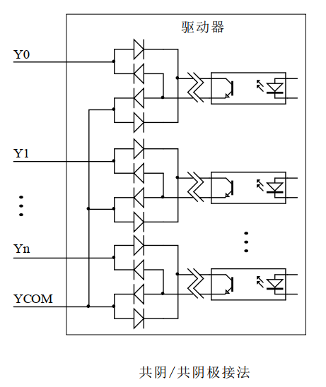
Figure 3.5 Output signal wiring diagram

3.6.2 Output signal interface function
The 485 bus type open and closed loop stepper driver has a variety of configurable functions on its output ports. Users can set the corresponding output IO port functions through the host computer. Each output IO port can be set to up to 11 functions, as shown in Table 3.11 below.
Table 3.11 Input/output interface function definition
name |  | illustrate | Functional Description
Output | Y0 | Low-speed digital signal  Output interface | 0: undefined;  1: Alarm output signal (0: normal 1: alarm);  2: In-position output signal (0: not in position 1: in position);  3:Axis lock status signal (0: release 1: lock);  4: motion status signal (0: stationary 1: moving);  5: Return to origin completion signal (0: not completed 1: completed);  6: Conducting origin signal;  7: Conducting positive limit signal;  8: Conduct negative limit signal;  9: Brake control signal (0: brake 1: release);  10: Z signal output (reserved);  11:Brake control PWM adaptive output signal (reserved);
Output | Y1 | Low-speed digital signal  Output interface
Output | Y2 | Low-speed digital signal  Output interface
Output | Y3 | Low-speed digital signal  Output interface
Output | Y4 | Low-speed digital signal  Output interface
Output | YCOM | Single-ended output common port  Compatible with common cathode and common anode | Compatible with both common cathode and common anode connections

3.6.3 Output signal interface function description
The output signal interface function description is shown in Table 3.12 below:
Table 3.12 Output interface function description
Function | describe
1: Alarm output signal | When the driver is in alarm state, the signal output is valid;
2: Output signal when in position | When the planned trajectory is completed in position mode, the signal output is valid;
3: Lock axis status signal | When the motor is in the locked shaft state, the signal output is valid;
4: Motion status signal | When the motor is in running state, the signal output is valid;  Note:The valid level state will be maintained for at least 20ms so that the master station can detect it;
5: Return to origin completion signal | After returning to the origin, the signal output is valid;
6: Conducting origin signal | When reaching the origin position, the signal output is valid;
7: Conducting positive limit signal | When the positive limit position is reached, the signal output is valid;
8: Conducting negative limit signal | When the negative limit position is reached, the signal output is valid;
9: Brake control signal | When the external brake control signal is input or the upper computer sets the brake control signal, the output of this bit is valid;
10: Z signal output (reserved) | Output encoder Z signal status;
11:Brake control PWM adaptive output signal (reserved); | For drivers with dedicated brake output circuits, the brake can be directly connected to the brake output port for control by configuring this output function;

3.6.4 Brake Motor Brake Wiring Diagram
The outputs of 485-bus open- and closed-loop stepper drivers include control functions for the brake motor's holding brake. Users simply set one of the output functions in the 'Output Port Function Selection' register to 'Brake Control Signal' on the host computer. This control is then achieved by configuring the registers in the 'Brake Control Parameter Group'.
The following figure is a schematic diagram of the wiring of the brake motor brake (Table 3.13 is a description of the relevant parameters in the diagram):
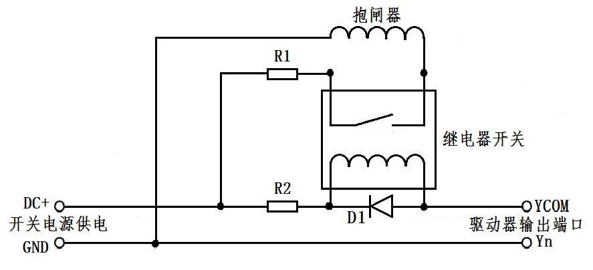
Figure 3.6 Brake motor brake wiring diagram
Table 3.13 Brake motor brake connection diagram parameter description
name | Logo | illustrate
Switching power supply | DC+ | Connect to +24 or +5V power supply
Switching power supply | GND | Ground terminal
Driver output port | YCOM | The common end of the single-ended output port is compatible with common cathode and common anode
Driver output port | Yn | One of the output ports needs to be configured as the 'brake control signal' function
protective resistor | R1 | If the brake is powered by DC24V, R1 can be smaller or not connected; if the brake is powered by DC5V, R1 should be larger.
protective resistor | R2 | R2 can be connected to a 1~2K resistor to limit the current to prevent damage to the optocoupler components inside the driver;  Please refer to the relay specification to determine whether it is necessary to connect;
Freewheeling diode | D1 | Protect the internal components of the driver from being damaged by induced voltage. Please refer to the relay specification to determine whether it is necessary to connect;
brake |  | The control mechanism of the brake motor is usually in the release state after the power is turned on, and the motor can run freely. Before use, you must confirm its power supply voltage to avoid excessive voltage and burn out the brake device;

3.7 Encoder input signal interface
name |  | illustrate | Function
Encoder | EB+ | Encoder interface | Connect encoder A and B signals, pay attention to the line sequence
Encoder | EB- | Encoder interface
Encoder | EA+ | Encoder interface
Encoder | EA- | Encoder interface
Encoder | +5V | Encoder power interface | Encoder 5V power supply positive terminal
Encoder | GND | Encoder power interface | Negative terminal of encoder 5V power supply

3.8 Motor Control Output Interface
name |  | illustrate | Function
Motor | A+ | Motor interface | Two-phase stepper motor wiring port  If it is a closed-loop motor, please pay attention to the line sequence
Motor | A- | Motor interface
Motor | B+ | Motor interface
Motor | B- | Motor interface

3.9 Power Input Interface
name |  | illustrate | Function
VAC/VDC | AC1/DC+ | Power interface | Power input  AC20V~50V/DC24V~70V
VAC/VDC | AC2/DC- | Power interface | Power input  AC20V~50V/DC24V~70V

4. MODBUS communication protocol and functions

4.1 Basic communication parameters
Table 4.1 Basic communication parameters
name | describe | Remark
Hardware Interface | RS485 | No RS232 support
Communication Type | Asynchronous half-duplex | Communication between master and slave devices
Baud rate | 9600 (default) | Can be set by dialing or host computer
Communication Protocol | MODBUS-RTU | -
Function code | 0x03: Read single or multiple data  0x06: Write single data  0x10: Write multiple data | -
Data character composition | Start bit: 1 bit Data bits: 8 bits  Parity bit: None (default) / Odd / Even Stop bit: 1 bit (default) / 2 bits | Communication data format
Verification method | CRC16 | Low position in front, high position in the back
Number of devices | 31 (default) | Higher configurable

485 bus single message communication rate:
Baud rate | Time from start of receiving to completion of sending T1 (ms)
115200 | 3.49
38400 | 6.30
19200 | 10.46
9600 | 20.32
When multiple axes send messages continuously, there will be a PLC processing waiting time T2 between messages. This value varies depending on the master station and baud rate.

4.2 MODBUS register address definition

4.2.1 Status parameter group (read-only)
Table 4.2 Status parameter group register
Register address | project | illustrate | Setting range  Note: Other values ​​are invalid | default value
Status parameter group (read-only)
0x0000 | Driver version | Driver version; | (read-only) | -
0x0001 | Drive label | The label of the same series of products is used to distinguish general products from customized products; | (read-only) | -
0x0002 | Drive node number | MODBUS current communication slave node number; | (read-only) | -
0x0003 | Driver operating mode | The corresponding bit is 1 to indicate the current working mode;  0x01: speed mode trigger;  0x02: Relative position mode trigger;  0x04: Absolute position mode trigger;  0x08: Return to origin mode is triggered;  0x1P: multi-segment position mode, P represents the corresponding path segment, and the P value range is 0-15;  0x2P: Multi-segment speed mode, P corresponds to the corresponding path segment, and the P value range is 0-15;  0x40: JOG+ motion;  0x80: JOG-motion;  Other values: invalid; | (read-only) | -
0x0004 | Drive Status | Bit0: release/enable status;  0: release;  1: Enable;  Bit1: stationary/moving status;  0: Still;  1: Exercise;  Bit2-Bit3: return to zero state;  0: invalid;  1: Returning to the origin;  2: Return to origin completed;  Bit4-Bit5: motor movement direction;  0: invalid, stop state;  1: Positive direction;  2: Reverse direction;  Bit6: Alarm status;  0: normal;  1: Alarm;  Bit7~Bit15: Reserved; | (read-only) | -
0x0005 | Current given theoretical speed | The current real-time given theoretical running speed value;  Unit: rev/min  This variable can be used to view the theoretical running trajectory of the motor; | (read-only) | -
0x0006 | Current actual running speed | The current actual running speed value;  Unit: rev/min | (read-only) | -
0x0007 | Current error code | 0: normal;  Other values: error code (see Section 4.2.13 for details);  Note: It is recommended to query registers 0x019A, 0x019C~0x019D to obtain alarm information; | (read-only) | -
0x0008 | Current error subcode | The error subcode corresponding to the current error code;  0: normal;  Other values: error subcode (see section 4.2.13 for details);  Note: It is recommended to query registers 0x019A, 0x019C~0x019D to obtain alarm information; | (read-only) | -
0x0009 | Input Port  Status flag | Indicates whether the level of the corresponding input port is valid or invalid;  Bit0: X0 port input status;  Bit1: X1 port input status;  Bit2: X2 port input status;  Bit3: X3 port input status;  Bit4: X4 port input status;  Bit5: X5 port input status;  Bit6: X6 port input status;  Bit7: X7 port input status;  Bit8: X8 port input status;  Bit9: X9 port input status;  Bit10: X10 port input status;  Bit11~Bit14: Reserved;  Bit15: Z signal status (reserved);  0: The input level of this port is considered invalid;  1: The input level of this port is considered valid; | (read-only) | -
0x000A | Output Port  Status flag | Indicates that the state of the corresponding output port is normally open or normally closed output;  Bit0: Y0 port output status;  Bit1: Y1 port output status;  Bit2: Y2 port output status;  Bit3: Y3 port output status;  Bit4: Y4 port output status;  Bit5~Bit15: Reserved;  0: The port output is normally open;  1: The port output is normally closed; | (read-only) | -
0x000B | Current position low | The lower 16 bits of the current position calculated with the position after returning to the origin as the zero point; | (read-only) | -
0x000C | Current position high | The current position calculated with the position after returning to the origin as the zero point is the high 16 bits (the highest bit is the sign bit, representing the positive and negative directions); | (read-only) | -
0x000D | Current actual current | In open-loop and closed-loop modes, the actual effective current value in the current operating state;  Unit: mA | (read-only) | -
0x000E | Current phase A current | Real-time display of phase A current;  Unit: mA | (read-only) | -
0x000F | Current B phase current | Real-time display of phase B current;  Unit: mA | (read-only) | -
0x0010 | Closed loop current setting | In closed-loop mode, the current running given effective current value;  Unit: mA | (read-only) | -
0x0011 | DIP status | Bit0: SW1 input status;  Bit1: SW2 input status;  Bit2: SW3 input status;  Bit3: SW4 input status;  Bit4: SW5 input status;  Bit5: SW6 input status;  Bit6: SW7 input status;  Bit7: SW8 input status;  Bit8: SW9 input status;  Bit10~Bit15: Reserved;  0: Input level is invalid;  1: Input level is valid; | (read-only) | -
0x0012 | PT segment path number | Lower 8 bits: path execution completion status (hold), used for query when the current path execution is completed;  High 8 bits: If in running state, it indicates the path segment currently being executed; if in static state, it indicates the path segment that was completed last time; | (read-only) | -
0x0013 | reserve;

4.2.2 Public parameter group 1 (read and write)
Table 4.3 Common parameter group registers
Register address | project | illustrate | Setting range  Note: Other values ​​are invalid | default value
Public parameter group 1 (shared by open and closed loop)
0x0014 | Driver Node Settings | When SW1-SW5 are all off, you can set the drive node number yourself;  1-31: SW1-SW5 dial settings;  32-65535: When the setting range of the DIP switch is insufficient, a new node can be set through this register;  Note: After modification, you need to save and re-power on to take effect; | 0-65535  (Read and Write) | 1
0x0015 | Custom communication baud  Rate | When the SW6 dial status is off, the communication baud rate can be set by the host computer;  0:9600  1:14400  2:19200  3:38400  4:115200  5:128000  6:256000  Note: After modification, you need to save and re-power on to take effect; | 0~6  (Read and Write) | 0
0x0016 | Serial port data format | 0: 8-bit data, no parity, 1 stop bit;  1: 8-bit data, no parity, 2 stop bits;  2: 8-bit data, even parity, 1 stop bit;  3: 8-bit data, odd parity, 1 stop bit;  Note: After modification, you need to save and re-power on to take effect; | 0~3  (Read and Write) | 0
0x0017 | Save parameter function | The corresponding bit position is 1, and the corresponding parameter group can be saved; the specific corresponding relationship is as follows:  Bit0: Synchronous update function (0x0001). It is generally not recommended to enable this function.  0: do not update EEPROM synchronously;  1: Synchronously update EEPROM;  Bit1: Reserved;  Bit2: Save common parameter group 1 (0x0004);  Bit3: Save open-loop common parameter group (0x0008);  Bit4: Save the closed-loop common parameter group (0x0010);  Bit5: Save basic control parameter group 1 (0x0020);  Bit6: Save the back-to-origin parameter group (0x0040);  Bit7: Save basic control parameter group 2 (0x0080);  Bit8: Save common parameter group 2 (0x0100);  Bit9: Save multi-segment mode parameter group (0x0200);  Bit10: Save performance parameter group (0x0400);  Bit11: Save brake parameter group (0x0800);  Bit12: Save status, fault code parameter group (0x1000);  Bit13: Save input and output parameter group (0x2000);  Bit14: Save user parameter group (0x4000);  Bit15: Save all parameters function (0x8000);  0: do not save;  1: Save all 'read and write' attribute parameters;  When using Bit1~Bit15 to save parameters, the red and green lights flash twice each alternately. When saving is completed, the green light remains on and the red light goes out. You can also query this bit through the master station. If it is 0, it means that the parameters are saved successfully. | 0~65535  (Read and Write) | 0
0x0018 | Overtravel parking function | Corresponding to Bit position 1, select the corresponding overtravel parking function;  Bit0: Free stop/emergency stop mode selection bit;  0: Free stop (decelerate and stop when overtravel);  1: Emergency stop (immediate stop when overtravel);  Bit1: Positive and negative hard limit overtravel prohibition function bit;  0: Disabled;  1: Disable (default)  Bit2: Positive and negative soft limit overtravel prohibition function bit;  0: Disabled;  1: Disable (default) | 0~7  (Read and Write) | 6
0x0019 | Alarm clear | 0: invalid;  1: Alarm cleared; | 0~1  (Read and Write) | 0
0x001A | Parameters restored to factory settings  Place | 0: invalid;  1: Restore factory settings; | 0~1  (Read and Write) | 0
0x001B | Storage function  Enable Control | The corresponding bit position is 1, which turns on the corresponding storage function;  Bit0: Phase memory enable function;  0: disabled;  1: Enable;  Bit1: Function of storing current position when power is off;  0: disabled;  1: Enable; | 0～3  (Read and Write) | 0
0x001C | Open/closed loop mode switching/  Initial rotation direction switch | Bit0: Open-loop and closed-loop mode switching (this bit setting is valid only when SW7 is off);  0: open loop mode;  1: Closed-loop mode;  Bit1: Initial rotation direction switch;  0: Factory default rotation direction;  1: The rotation direction is opposite to the factory default;  Note: After modification, you need to save and re-power on to take effect; | 0~3  (Read and Write) | 0
0x001D | Return to origin timeout alarm setting | In homing mode, timeout alarm time setting;  Unit: s | 0~4000  (Read and Write) | 1000

4.2.3 Common parameters in open loop mode (read and write)
Table 4.4 Common parameter group registers in open loop mode
Register address | project | illustrate | Setting range  Note: Other values ​​are invalid | default value
Common parameter groups in open-loop mode
0x001E | Open loop current setting | When SW8-SW9 are all off, the effective current value of the drive can be adjusted arbitrarily;  Unit: mA | 0~6000  (Read and Write) | -
0x001F | Open loop subdivision setting | Arbitrarily set the subdivision value in open-loop mode;  Unit: Pul/rev | 200~60000  (Read and Write) | 10000
0x0020 | Open loop soft start time | Unit: ms | 1～1000  (Read and Write) | 200
0x0021 | Open loop lock machine current time | The time required for the open loop to go from running to locking state;  Unit: ms | 1～1000  (Read and Write) | 200
0x0022 | Open loop lock current ratio | Set the lock current percentage in open loop mode;  unit:% | 0~100  (Read and Write) | 50
0x0023 | Open-loop algorithm selection | 0: A algorithm;  1: B algorithm (reserved);  Note: After modification, you need to save and re-power on to take effect; | 0~1  (Read and Write) | 0

4.2.4 Common parameter group in closed loop mode (read and write)
Table 4.5 Common parameter group registers in closed-loop mode
Register address | project | illustrate | Setting range  Note: Other values ​​are invalid | default value
Common parameter groups in closed-loop mode
0x0024 | Minimum effective current setting for closed loop operation | When SW8-SW9 are off, the minimum effective current value of closed-loop operation can be adjusted arbitrarily:  Unit: mA | 0～6000  (Read and Write) | -
0x0025 | Maximum effective current setting for closed-loop operation | When SW8-SW9 is off, the maximum effective current value of closed-loop operation can be adjusted arbitrarily;  Unit: mA | 0～6000  (Read and Write) | -
0x0026 | Minimum effective current setting for closed-loop locking machine | When SW8-SW9 is off, the minimum effective current value of the closed-loop lock machine can be adjusted arbitrarily:  Unit: mA | 0～6000  (Read and Write) | -
0x0027 | Closed-loop lock machine maximum current setting | When SW8-SW9 is off, the maximum effective current value of the closed-loop lock machine can be adjusted arbitrarily;  Unit: mA | 0～6000  (Read and Write) | -
0x0028 | Closed-loop subdivision settings | The subdivision value in closed-loop mode can be set arbitrarily;  Unit: Pul/rev | 200～60000  (Read and Write) | 10000
0x0029 | Closed loop soft start time T1 | Unit: ms | 1～65535  (Read and Write) | 410
0x002A | Closed loop soft start time T2 | Unit: ms | 1～65535  (Read and Write) | 1000
0x002B | Closed-loop locking time | The time required for the closed loop to switch from the running state to the in-position signal output state;  Unit: ms | 1～500  (Read and Write) | 2
0x002C | Closed-loop position out-of-tolerance alarm value | Set the out-of-tolerance alarm angle value;  Unit: 1 represents 0.09° | 1~65535  (Read and Write) | 4000
0x002D | Closed loop out-of-tolerance alarm time | The cumulative time from deviation to output of alarm signal;  Unit: ms | 1~1000  (Read and Write) | 10
0x002E | Torque mode selection | 0: Normal closed-loop mode (will enter out-of-tolerance alarm and output alarm signal);  1: Normal closed-loop torque mode (will not enter the out-of-tolerance alarm, but can output the alarm signal); | 0～1  (Read and Write) | 0
0x002F | Closed-loop algorithm selection | Bit0: Operation mode selection bit;  0: Operation control mode A;  1: Operation control mode B;  Bit1: current control mode selection bit;  0: Current control mode A;  1: Current control mode B;  Bit2: Lock control mode selection bit;  0: Lock control mode A;  1: Lock control mode B;  Bit3: Closed-loop power-on locking mode;  0: After the power-on soft start is completed, the closed loop locks the machine;  1: After the power-on soft start is completed, the machine is locked in the open loop;  Note: After modification, power must be turned on again to take effect; | 0～15  (Read and Write) | 0

4.2.5 Driver basic control parameter group 1 (read and write)
Table 4.6 Driver Basic Control Parameter Group 1 Register
Register address | project | illustrate | Setting range  Note: Other values ​​are invalid | default value
Driver basic control parameter group 1 (shared for open and closed loop)
0x0030 | Starting speed | Set the starting speed of the motor;  Unit: rev/min | 1-3000  (Read and Write) | 5
0x0031 | Acceleration time | Acceleration time;  Unit: ms | 0~2000  (Read and Write) | 100
0x0032 | Deceleration time | deceleration time;  Unit: ms | 0~2000  (Read and Write) | 100
0x0033 | Maximum speed | Set the maximum speed of the motor;  Unit: rev/min  Note: In speed mode, the direction of the motor is determined by the positive or negative value of the set value. For the setting rules of negative values, please refer to the introduction of register '0x0034~0x0035 total pulse number'; | -3000~3000  (Read and Write) | 60
0x0034 | Total pulse number low 16 bits | In position mode, the total number of pulses of the motor running, including the total number of steps in the three stages of acceleration, constant speed, and deceleration; the highest bit represents the sign bit, a positive number represents the number of pulses running in the forward direction, and a negative number represents the number of pulses running in the reverse direction;  Note: If 100000 (original code: 0x0001 86A0) pulses are set, the high-order given value is 0x0001 and the low-order given value is 0x86A0;  For example, if -100000 (original code: 0x8001 86A0) pulses are set, since negative numbers are stored in the form of two's complement, the high-order given value is 0xFFFE and the low-order given value is 0x7960.  The given pulse number in the reverse direction can be calculated using the following formula:  2^32-abs (number of pulses given in the reverse direction) | -2147483648~  2147483648  (Read and Write) | 5000
0x0035 | High 16 bits of total pulse number |  | -2147483648~  2147483648  (Read and Write) | 5000
0x0036 | Relative position/absolute position  Setting selection | When the external IO signal is selected to trigger the position mode, this bit setting is valid;  0: relative position: take the current static point as the starting point;  1: Absolute position: The starting point is the position after power-on or homing. | 0~1  (Read and Write) | 0
0x0037 | Startup Command | The corresponding bit position 1 can trigger the corresponding working mode;  0x01: speed mode trigger;  0x02: Relative position mode trigger;  0x04: Absolute position mode trigger;  0x08: Return to origin mode is triggered;  0x1P: Multi-segment (position/speed) mode trigger start, P is the corresponding path segment, the P value range is 0-15, the specific trigger start position or speed operation is related to the path function register 1;  0x40: JOG+ motion;  0x80: JOG-motion;  Other values: reserved; | 0~255  (Read and Write) | 0
0x0038 | Stop Command | 0: normal stop;  1: Emergency stop;  2: Run at the set speed or along the planned trajectory until it stops; | 0~2  (Read and Write) | 2
0x0039 | Motor enable//release  Order | The motor enable/release function can be controlled by instructions or external IO input signals.  The following are the functions of the corresponding bits of this register:  Bit0: soft enable bit;  0: release;  1: Enable;  Bit1: Initial power-on, motor self-enable control bit;  0: After power-on, the motor is in the released state and you need to set Bit 0 to 1 to enable the motor lock.  1: After power-on, the motor is in the locked state, but it can be released by setting Bit 0 to 0;  Note: If the function of a certain input port is configured as 4 (motor MF enable/release signal), the IO port motor enable/release function is only valid when Bit 0 of the register is 0; | 0~3  (Read and Write) | 0
0x003A | Clear current location | In absolute position mode, clear the current position value;  0: invalid;  1: current position is cleared to 0; | 0~1  (Read and Write) | 0

4.2.6 Return to origin parameter group (read and write)
Table 4.7 Return to origin parameter group register
Register address | project | illustrate | Setting range  Note: Other values ​​are invalid | default value
Return to origin parameter group (shared for open and closed loop)
0x003B | Return to origin mode | Currently, the return-to-zero mode can be set to (-3)-(-6), 17-30, 33-35, 37-39, 41-48;  Note: The highest bit represents the sign bit;  For details on the return to origin method, please refer to section '5.3 Return to Origin Mode'; | 0~65535  (Read and Write) | 0
0x003C | Return to origin speed V1 | In the homing mode, the speed of the origin is detected at high speed;  Unit: rev/min  Note: The starting speed of high-speed origin detection is '0x003D Home Speed ​​V2'; | 1~3000  (Read and Write) | 30
0x003D | Return to origin speed V2 | In homing mode, the origin is detected at low speed or the speed of the compensation value;  Unit: rev/min  Note: The starting speed of low-speed detection origin or compensation value is 0; | 1~300  (Read and Write) | 10
0x003E | Return to origin acceleration time | Acceleration time during the return to origin process;  Unit: ms | 0 ~2000  (Read and Write) | 100
0x003F | Return to origin deceleration time | Deceleration time during homing;  Unit: ms | 0 ~2000  (Read and Write) | 100
0x0040 | Origin low position compensation value | Position compensation value after returning to the origin;  The highest bit represents the sign bit, a positive value represents a positive compensation value, and a negative value represents a negative compensation value;  Note: If 100000 (original code: 0x0001 86A0) pulses are set, the high-order given value is 0x0001 and the low-order given value is 0x86A0;  For example, if -100000 (original code: 0x8001 86A0) pulses are set, since negative numbers are stored in the form of two's complement, the high-order given value is 0xFFFE and the low-order given value is 0x7960.  The given pulse number in the reverse direction can be calculated using the following formula:  2^32-abs (number of pulses given in the reverse direction) | -2147483648~  2147483648  (Read and Write) | 0
0x0041 | Origin high position compensation value |  | -2147483648~  2147483648  (Read and Write) | 0
0x0042 | Stalled-rotor return to zero torque retention time | Unit: ms | 0-65535  (Read and Write) | 100
0x0043 | Return to zero current percentage | unit:% | 1~300 | 100
0x0044 | Open and closed loop position return to zero  Lower 16 bits of position value | In the open-loop and closed-loop position return mode, the maximum operating position value is set, without a sign; | 0~4294967295  (Read and Write) | 5000
0x0045 | Open and closed loop position return to zero  Position value high 16 bits |  | 0~4294967295  (Read and Write) | 5000

4.2.7 Driver Basic Control Parameter Group 2 (Read and Write)
Table 4.8 Driver basic control parameter group 2 register
Register address | project | illustrate | Setting range  Note: Other values ​​are invalid | default value
Driver basic control parameter group 2 (shared for open and closed loop)
0x0046 | JOG motion starting speed | Unsigned  Unit: rev/min | 1~3000  (Read and Write) | 2
0x0047 | JOG motion acceleration speed | Unit: ms | 0~2000  (Read and Write) | 2
0x0048 | JOG motion deceleration speed | Unit: ms | 0~2000  (Read and Write) | 2
0x0049 | JOG movement maximum speed | Unsigned;  Unit: rev/min | 0~3000  (Read and Write) | 30
0x004A~  0x0055 | reserve;

4.2.8 Public Parameter Group 2 (Read and Write)
Table 4.9 Common parameter group 2 registers
Register address | project | illustrate | Setting range  Note: Other values ​​are invalid | default value
Public parameter group 2 (shared for open and closed loop)
0x0056 | Positive overtravel maximum position low 16 bits | Unsigned;  Unit: Pul | 0~2147483647  (Read and Write) | 2147483647
0x0057 | Positive overtravel maximum position high 16 bits | Unsigned;  Unit: Pul | 0~2147483647  (Read and Write) | 2147483647
0x0058 | Low 16 bits of the maximum position of reverse overtravel | Unsigned;  Unit: Pul | 0~2147483647  (Read and Write) | 2147483647
0x0059 | Reverse overtravel maximum position high 16 bits | Unsigned;  Unit: Pul | 0~2147483647  (Read and Write) | 2147483647
0x005A | Automatically return to zero point after power on  Enable | If this function is turned on, the drive will automatically enable after power-on and perform the zero point return action. However, please note that the zero point return method parameter values ​​must be set and saved in advance so that the zero point return action can be performed normally after power-on.  0: The automatic return to zero point function at power on is disabled;  1: Enable the automatic return to zero point function upon power on; | 0~1  (Read and Write) | 0
0x005B~  0x005D | reserve;

4.2.9 Input and output function parameter group (read and write)
Table 4.10 Input and output function parameter group register
Register address | project | illustrate | Setting range  Note: Other values ​​are invalid | default value
Input and output function parameter group (shared for open and closed loop)
0x01B0 | Input Port  Effective level | Bit0: input port X0 control bit;  Bit1: input port X1 control bit;  Bit2: input port X2 control bit;  Bit3: input port X3 control bit;  Bit4: input port X4 control bit;  Bit5: input port X5 control bit;  Bit6: input port X6 control bit;  Bit7: input port X7 control bit;  Bit8: input port X8 control bit;  Bit9: input port X9 control bit;  Bit10: input port X10 control bit;  Bit11~Bit15: Reserved;  0: rising edge or high level is valid;  1: Falling edge or low level is valid; | 0~65535  (Read and Write) | 0
0x01B1 | Input port X0  Function selection | 0: undefined;  1: Origin signal;  2: Positive limit signal;  3: Negative limit signal;  4: Motor MF enable/release signal (when the value of register 0x0039 is 1~3, this input control function is invalid);  5: Brake control input signal;  6: Alarm clear signal;  7: Parameters are restored to factory settings;  8: Normal stop signal;  9: Emergency stop signal;  10: Trigger position mode motion (relative and absolute position modes are selected via register 0x0036);  11: Trigger speed mode motion;  12: JOG+point motion;  13: JOG-point movement;  14: Return to origin enable signal (used in conjunction with the return to origin mode register);  15: PTIN0;  16:PTIN1;  17:PTIN2;  18:PTIN3;  19: Reserved;  20: Multi-stage mode start signal (TRIG);  21: Clear the in-place output signal;  Note: In the above function selection: Signals 4, 5, 12, 13, and 15-20 are valid at high level or low level, and the others are valid at rising edge or falling edge; | 0~21  (Read and Write) | 1
0x01B2 | Input port X1  Function selection |  | 0~21  (Read and Write) | 2
0x01B3 | Input port X2  Function selection |  | 0~21  (Read and Write) | 3
0x01B4 | Input port X3  Function selection |  | 0~21  (Read and Write) | 0
0x01B5 | Input port X4  Function selection |  | 0~21  (Read and Write) | 0
0x01B6 | Input port X5  Function selection |  | 0~21  (Read and Write) | 0
0x01B7 | Input port X6  Function selection |  | 0~21  (Read and Write) | 0
0x01B8 | Input port X7  Function selection |  | 0~21  (Read and Write) | 0
0x01B9 | Input port X8  Function selection |  | 0~21  (Read and Write) | 0
0x01BA | Input port X9  Function selection |  | 0~21  (Read and Write) | 0
0x01BB | Input port X10  Function selection |  | 0~21  (Read and Write) | 0
0x01BC | Input port X0  Filter time | Set the filter time of input port X0-X10, with a minimum resolution of 1000us;  Unit: us | 0~65535  (Read and Write) | 1000
0x01BD | Input port X1  Filter time |  | 0~65535  (Read and Write) | 1000
0x01BE | Input port X2  Filter time |  | 0~65535  (Read and Write) | 1000
0x01BF | Input port X3  Filter time |  | 0~65535  (Read and Write) | 1000
0x01C0 | Input port X4  Filter time |  | 0~65535  (Read and Write) | 1000
0x01C1 | Input port X5  Filter time |  | 0~65535  (Read and Write) | 1000
0x01C2 | Input port X6  Filter time |  | 0~65535  (Read and Write) | 1000
0x01C3 | Input port X7  Filter time |  | 0~65535  (Read and Write) | 1000
0x01C4 | Input port X8  Filter time |  | 0~65535  (Read and Write) | 1000
0x01C5 | Input port X9  Filter time |  | 0~65535  (Read and Write) | 1000
0x01C6 | Input port X10  Filter time |  | 0~65535  (Read and Write) | 1000
0x01C7 | Output Port  Valid status | Bit0: output port Y0 control bit;  Bit1: output port Y1 control bit;  Bit2: output port Y2 control bit;  Bit3: output port Y3 control bit;  Bit4: output port Y4 control bit;  Bit5~Bit15: Reserved;  0: After power on, the default is normally open output;  1: After power on, the default is normally closed output; | 0~65535  (Read and Write) | 0
0x01C8 | Output port Y0  Function selection | 0: undefined;  1: Alarm output signal;  2: Output signal when in position;  3:Axis lock status signal (0: release 1: lock);  4: motion status signal (0: stationary 1: moving);  5: Return to origin completion signal;  6: Conduction origin signal status;  7: Conduction positive limit signal status;  8: Conduction negative limit signal status;  9: Brake control signal;  10: Z signal output (reserved);  11:Brake control PWM adaptive output signal (reserved); | 0~11  (Read and Write) | 5
0x01C9 | Output port Y1  Function selection |  | 0~11  (Read and Write) | 4
0x01CA | Output port Y2  Function selection |  | 0~11  (Read and Write) | 0
0x01CB | Output port Y3  Function selection |  | 0~11  (Read and Write) | 0
0x01CC | Output port Y4  Function selection |  | 0~11  (Read and Write) | 0
0x01CD | Disable in-position output in different modes | Bit0: speed mode; Bit1: relative position;  Bit2: absolute position; Bit3: return to zero;  Bit4: multi-stage position; Bit5: multi-stage speed;  Bit6: JOG+ motion; Bit7: JOG- motion;  0: Disabled;  1: prohibition is effective;  Note: The corresponding bit is disabled in multi-segment mode, which is only valid when powered on. The subsequent status is determined by function register 1. | 0~65535  (Read and Write) | 0
0x01CE~  0x01CF | reserve;

4.2.10 Multi-segment mode parameter group (read and write)
Table 4.11 Multi-segment mode parameter group register
Register address | project | illustrate | Setting range  Note: Other values ​​are invalid | default value
Multi-position mode parameter group (shared for open and closed loop)
0x005E | Multi-stage mode start signal enable control | 0: Multi-stage mode does not require a start signal (path 0 is invalid in this case);  1: Multi-stage mode requires a start signal (path 0 can be started in this case); | 0-1  (Read and Write) | 1
0x005F | Multi-segment mode IO combination  Filter time | Set the multi-segment IO combination logic filter time, with a minimum resolution of 1000us;  Unit: us | 0~65535  (Read and Write) | 1000
0x0060 | Path 0 function setting 1 | In multi-segment mode, path 0 function setting 1:  The corresponding bit setting can select the corresponding function;  Bit0: Position/speed mode selection bit;  0: Position mode;  1: Speed ​​mode;  Bit1: relative/absolute position mode selection bit;  0: relative position;  1: absolute position;  Bit2: IO in place output signal disabled;  0: Disabled;  1: prohibition is effective;  Bit3: Jump function enable bit;  0: jump is disabled;  1: Enable jump;  Bit4~Bit7: jump path selection bit;  Setting value range: 0-15;  Bit8~Bit15: Reserved;  Note: In multi-speed mode, the jump function is not supported; | 0~65535  (Read and Write) | 0
0x0061 | Path 0 function setting 2 | In multi-segment mode, path 0 function setting 2:  The corresponding bit setting can select the corresponding function;  Bit0: homing enable bit;  0: prohibit the path from returning to the origin;  1: Enable the path to return to the origin;  Bit1: whether to execute the path after returning to the original state;  0: prohibit execution of this path;  1: Enable execution of this path;  Bit2: selection of return to origin parameters;  0: Select the speed, acceleration/deceleration time, and return compensation value parameters of 0x003C-0x0041;  1: Select the speed, acceleration/deceleration time, and return compensation value parameters for this path segment;  Bit3-Bit7: Reserved;  Bit8~Bit15: Return to origin mode selection bits; for details on the return to origin mode, see section '5.3 Return to origin mode'; | 0~65535  (Read and Write) | 0
0x0062 | Path 0 position segment  Total pulse count low | In multi-segment position mode, it is used to set the total number of pulses for the path segment, including the total number of steps in the three stages of acceleration, constant speed, and deceleration;  The highest bit represents the sign bit. A positive number represents the number of pulses running in the positive direction, and a negative number represents the number of pulses running in the reverse direction.  Note: If 100000 (original code: 0x0001 86A0) pulses are set, the high-order given value is 0x0001 and the low-order given value is 0x86A0;  For example, if -100000 (original code: 0x8001 86A0) pulses are set, since negative numbers are stored in the form of two's complement, the high-order given value is 0xFFFE and the low-order given value is 0x7960.  The given pulse number in the reverse direction can be calculated using the following formula:  2^32-abs (number of pulses given in the reverse direction) | -2147483648~  2147483648  (Read and Write) | 0
0x0063 | Path 0 position segment  Total pulse count high |  | -2147483648~  2147483648  (Read and Write) | 0
0x0064 | Path 0 run/return to origin  Maximum speed | (1) In the multi-position/speed mode, set the maximum speed of the motor within the corresponding path;  (2) If the path segment has the homing function enabled and Bit 2 of the register 'Path Function Setting 2' is set to 1, then the 'Homing Speed ​​V1' uses the value of this register;  Unit: rev/min  Note: (1) In the multi-speed mode, the direction of the motor is determined by the positive or negative value of the set value; the setting rules for negative values ​​can refer to the introduction of register '0x0034~0x0035 total pulse number';  (2) The multi-position mode and the return to zero speed settings must be positive values; | -3000~3000  (Read and Write) | 60
0x0065 | Path 0 run/return to origin  Starting speed | - In multi-position/speed mode, set the starting speed of the motor within the corresponding path;  (2) If the path segment has the homing function enabled and Bit 2 of the register 'Path Function Setting 2' is set to 1, then the 'Homing Speed ​​V2' uses this value;  Unit: rev/min | 1~3000  (Read and Write) | 5
0x0066 | Path 0 run/return to origin  Acceleration time | - In multi-position/speed mode, set the acceleration time within the corresponding path;  - If the path segment has the homing function enabled and Bit 2 of the register 'Path Function Setting 2' is set to 1, the 'Homing Acceleration Time' uses the value of this register;  Unit: ms | 0~2000  (Read and Write) | 100
0x0067 | Path 0 run/return to origin  Deceleration time | - In multi-position/speed mode, set the deceleration time within the corresponding path;  - If the homing function is enabled for this path segment and Bit 2 of the register 'Path Function Setting 2' is set to 1, the 'Home Deceleration Time' uses the value of this register;  Unit: ms | 0~2000  (Read and Write) | 100
0x0068 | Path 0 completed  Waiting time | In multi-segment loop mode, the waiting time after the current path segment is executed and before the next path segment is executed;  Unit: ms | 0~65535  (Read and Write) | 0
0x0069 | Path 0 back to origin  Low compensation value | In multi-segment mode, the position compensation value after the current path returns to the origin;  The highest bit represents the sign bit, a positive value represents a positive compensation value, and a negative value represents a negative compensation value;  Note: If 100000 (original code: 0x0001 86A0) pulses are set, the high-order given value is 0x0001 and the low-order given value is 0x86A0;  For example, if -100000 (original code: 0x8001 86A0) pulses are set, since negative numbers are stored in the form of two's complement, the high-order given value is 0xFFFE and the low-order given value is 0x7960.  The given pulse number in the reverse direction can be calculated using the following formula:  2^32-abs (number of pulses given in the reverse direction) | -2147483648~  2147483648  (Read and Write) | 0
0x006A | Path 0 back to origin  High compensation value |  | -2147483648~  2147483648  (Read and Write) | 0
0x006B | After path 0 returns to the origin  Waiting time | In multi-segment mode, after path 0 returns to the origin, the waiting time before the execution of the path segment is completed;  Unit: ms | 0~65535  (Read and Write) | 0
0x0070~  0x007B | Comparing the function of path 0, path 1 related setting registers occupy 12 registers
0x0080~  0x008B | Comparing the function of path 0, path 2 related setting registers occupy 12 registers
0x0090~  0x009B | Comparing the function of path 0, path 3 related setting registers occupy 12 registers
0x00A0~  0x00AB | Comparing the function of path 0, path 4 related setting registers occupy 12 registers
0x00B0~  0x00BB | Comparing the function of path 0, path 5 related setting registers occupy 12 registers
0x00C0~  0x00CB | Comparing the function of path 0, path 6 related setting registers occupy 12 registers
0x00D0~  0x00DB | Comparing the function of path 0, path 7 related setting registers occupy 12 registers
0x00E0~  0x00EB | Comparing the function of path 0, the related setting registers of path 8 occupy 12 registers.
0x00F0~  0x00FB | Comparing the function of path 0, path 9 related setting registers occupy 12 registers
0x0100~  0x010B | Comparing the function of path 0, the related setting registers of path 10 occupy 12 registers.
0x0110~  0x011B | Comparing the function of path 0, path 11 related setting registers occupy 12 registers
0x0120~  0x012B | Comparing the function of path 0, the related setting registers of path 12 occupy 12 registers.
0x0130~  0x013B | Comparing the function of path 0, the related setting registers of path 13 occupy 12 registers.
0x0140~  0x014B | Comparing the function of path 0, the related setting registers of path 14 occupy 12 registers.
0x0150~  0x015B | Comparing the function of path 0, the related setting registers of path 15 occupy 12 registers.
Note: The unused registers in the range of 0x0060~0x015F are reserved registers of each path and have no function at present.

4.2.11 Performance parameter group (read and write)
Table 4.12 Performance parameter group registers
Register address | project | illustrate | Setting range  Note: Other values ​​are invalid | default value
Performance parameter group
0x0160 | Phase loss detection threshold | Set the threshold value for the phase loss detection function;  Note: After modification, you need to save and re-power on to take effect; | 0~100  (Read and Write) | -
0x0161 | Open and closed loop current setting  Control factor adjustment | Open and closed loop current given control factor adjustment percentage;  unit:% | 0～500  (Read and Write) | 100
0x0162 | Enable intermediate frequency oscillation processing | 0: oscillation processing is disabled;  1: Oscillation processing is enabled; | 0~1  (Read and Write) | 1
0x0163 | Medium frequency oscillation  Suppression coefficient K | Adjustment percentage of intermediate frequency oscillation suppression coefficient K;  unit:% | 0～500  (Read and Write) | 100
0x0164 | Medium frequency oscillation  Starting speed V1 | Set the medium frequency oscillation starting speed V1;  Unit: rev/min | 1~2000  (Read and Write) | -
0x0165 | Medium frequency oscillation  Maximum speed V2 | Set the maximum speed of medium frequency oscillation V2;  Unit: rev/min | 1~2000  (Read and Write) | -
0x0166 | Motor winding resistance adjustment | Motor winding resistance adjustment percentage;  unit:% | 0～500  (Read and Write) | 100
0x0167 | Open current loop  Parameter adjustment enable | 0: PI parameter adjustment is disabled  1: PI parameter adjustment enabled | 0～1  (Read and Write) | 0
0x0168 | Open current loop  Proportional gain | Open loop current loop proportional gain adjustment percentage;  unit:% | 0～500  (Read and Write) | 100
0x0169 | Open current loop  Integral gain | Open-loop current loop integral gain adjustment percentage;  unit:% | 0～500  (Read and Write) | 100
0x016A | Open ring shaft  Proportional gain | Open loop axis proportional gain adjustment percentage;  unit:% | 0～500  (Read and Write) | 100
0x016B | Open ring shaft  Integral gain | Open-loop axis integral gain adjustment percentage;  unit:% | 0～500  (Read and Write) | 100
0x016C | Open-loop proportional gain  Adaptive adjustment enabled | 0: Proportional gain adaptive adjustment is disabled  1: Proportional gain adaptive adjustment enabled | 0～1  (Read and Write) | 0
0x016D | Open-loop proportional gain  Adaptive starting ratio | Open loop proportional gain adaptive starting ratio adjustment per thousandth;  For example, if the setting value is 800, the corresponding open-loop proportional gain adaptive starting ratio is 0.8 times; | 1~1000  (Read and Write) | 800
0x016E | Open-loop proportional gain  Adaptive starting speed V1 | Open loop proportional gain adaptive starting speed V1;  Unit: rev/min | 1~2000  (Read and Write) | 60
0x016F | Open-loop proportional gain  Adaptive turning speed V2 | Open loop proportional gain adaptive turning speed V2;  Unit: rev/min | 1~2000  (Read and Write) | 900
0x0170 | Open-loop proportional gain  Adaptive Limiting | Open loop proportional gain adaptive limit percentage;  unit:% | 100~500  (Read and Write) | 150
0x0171 | Open-loop current  Adaptive adjustment enabled | 0: Current adaptive regulation is disabled  1: Current adaptive regulation enabled | 0～1  (Read and Write) | 0
0x0172 | Open-loop current  Adaptive Adjustment  Starting speed V1 | Open loop current adaptively adjusts the starting speed V1;  Unit: rev/min | 1~2000  (Read and Write) | 120
0x0173 | Open-loop current  Adaptive Adjustment  Maximum speed V2 | Open-loop current adaptively adjusts the maximum speed V2;  Unit: rev/min | 1~2000  (Read and Write) | 600
0x0174 | Open-loop current  Adaptive Adjustment  Maximum limit | Open loop current adaptive regulation maximum limit adjustment percentage;  unit:% | 100~200  (Read and Write) | 120
0x0175 | Open and closed loop power-up current  Percentage adjustment | unit:% | 0～500  (Read and Write) | 100
0x0176 | Brake control duty cycle  adjust | Taking DC24V as the reference voltage, adjust the proportion of the brake control interface output voltage;  unit:% | 0~110  (Read and Write) | 96
0x0177 | Closed current loop  Proportional coefficient | Closed-loop current loop proportional coefficient gain adjustment percentage;  unit:% | 0～500  (Read and Write) | 100
0x0178 | Closed current loop  Integration coefficient | Closed-loop current loop integral coefficient gain adjustment percentage;  unit:% | 0～500  (Read and Write) | 100
0x0179 | Closed-loop position loop  Proportional coefficient | Closed loop position loop proportional coefficient adjustment percentage;  unit:% | 0～500  (Read and Write) | 100
0x017A | Closed-loop position loop  Integration coefficient | Closed-loop position loop integral coefficient adjustment percentage;  unit:% | 0～500  (Read and Write) | 100
0x017B | Closed-loop locking current  Proportional coefficient | Closed-loop lock machine current proportional coefficient adjustment percentage;  unit:% | 0～500  (Read and Write) | 100
0x017C | Closed-loop locking current  Integration coefficient | Closed-loop locking machine current integral coefficient adjustment percentage;  unit:% | 0～500  (Read and Write) | 100
0x017D | Closed-loop speed loop  Proportional coefficient | Closed loop speed loop proportional coefficient adjustment percentage;  unit:% | 0～500  (Read and Write) | 100
0x017E | Closed-loop speed loop  Feedforward coefficient | Closed-loop speed loop feedforward coefficient adjustment percentage;  unit:% | 0～500  (Read and Write) | 100
0x017F | Closed loop given speed  Filter coefficient F1 | Closed loop given speed filter coefficient F1 adjustment percentage;  unit:% | 0～500  (Read and Write) | 100
0x0180 | Closed loop given speed  Filter coefficient F2 | Closed loop given speed filter coefficient F2 adjustment percentage;  unit:% | 0～500  (Read and Write) | 100
0x0181 | Encoder feedback speed  Filter coefficient F1 | Encoder feedback speed filter coefficient F1 adjustment percentage;  unit:% | 0～500  (Read and Write) | 100
0x0182 | Encoder feedback speed  Filter coefficient F2 | Encoder feedback speed filter coefficient F2 adjustment percentage;  unit:% | 0～500  (Read and Write) | 100
0x0183 | Incremental closed-loop encoder line number setting | The number of encoder lines can be set by the host computer;  0: 1000 lines; 1: 1250 lines;  2: 2000 lines; 3: 2500 lines;  4: 5000 lines; 5: 10000 lines;  6: 625 lines; 7: 500 lines;  8:400 line; 9:250 line;  10:200 line; 11:125 line;  12:100 line; 13:80 line;  14:50 line;  Note: (1) After modification, you need to save and re-power on to take effect;  (2) If you need other line numbers, it is recommended to contact our company first to make changes; | 0～14  (Read and Write) | 0
0x0184 | Closed-loop locking machine positioning accuracy threshold 1 | Set the positioning accuracy threshold of the closed-loop locking machine to 1;  Unit: 0.1 encoder value | 0~65535  (Read and Write) | 25
0x0185 | Closed-loop locking current  Dynamic adjustment parameter 1 | Closed-loop locking machine current dynamic parameter adjustment 1;  Unit: 0.01mA | 1~65535  (Read and Write) | 38
0x0186 | Closed-loop locking current  Dynamic adjustment parameter 2 | Closed-loop locking machine current dynamic parameter adjustment 2;  Unit: 0.01mA | 1~65535  (Read and Write) | 38
0x0187 | Open and closed loop alarm detection  Enable | Open and closed loop alarm detection enable control:  0: Disable the corresponding alarm function;  1: Enable the corresponding alarm function;  The following are the control functions of the corresponding bits:  Bit0: overcurrent alarm;  Bit1: Over-voltage or under-voltage alarm;  Bit2~Bit3: Reserved;  Bit4: Phase loss alarm;  Bit5: Reserved;  Bit6: Return to origin timeout alarm;  Bit7: out-of-tolerance alarm;  Bit8~Bit15: Reserved; | 0~65535  (Read and Write) | 255
0x0188 | Stalled rotor return to zero error limit | set upStalled rotor return to zero error limit value;  Unit: 1 represents 0.09° | 1~65535  (Read and Write) | 500
0x0189 | Closed-loop locking machine positioning accuracy threshold 2 | Set the positioning accuracy threshold of the closed-loop locking machine to 2;  Unit: 0.1 encoder value | 0~65535  (Read and Write) | 25
0x018A | Closed-loop lock integral enable | Closed-loop lock state, integral enabled;  0: disabled;  1: Enable; | 0~1 | 0
0x018B | Closed-loop locking machine integral limit adjustment | Closed-loop lock machine integral limit percentage adjustment;  unit:% | 0~1000 | 100
0x018C | Closed-loop lock machine B algorithm  Threshold 1 | Closed-loop lock machine B algorithm threshold 1;  Unit: 0.1 encoder value | 0~65535  (Read and Write) | 10
0x018D | Closed-loop lock machine B algorithm  Threshold 2 | Closed-loop lock machine B algorithm threshold 2;  Unit: 0.1 encoder value | 0~65535  (Read and Write) | 20
0x018E | Phase storage time | Phase storage time;  Unit: ms | 500~65535 | 1000
0x018F | Mechanical transmission ratio | For stepper motors with reducers;  Mechanical transmission ratio = reduction gear / motor gear;  High 8 bits: represents the reduction gear;  Lower 8 bits: represents the motor gear;  For example: If it is a 10-ratio reducer, set the parameter to 0x010A;  Please note that if the mechanical transmission ratio is not 1, the parameters of the position and speed related registers will actually correspond to the position and speed values ​​output after the reducer (which have been converted within the program).  Note: After modification, save the parameters and re-power on to take effect; | 0x0101~0x3232 | 0x0101

4.2.12 Brake Control Parameter Group (Read and Write)
Table 4.13 Brake Control Parameter Group Register
Register address | project | illustrate | Setting range  Note: Other values ​​are invalid | default value
Brake control parameter group
0x0190 | Brake engagement delay | Brake engagement (brake holding) delay time;  Unit: ms | 0~65535  (Read and Write) | 0
0x0191 | Brake release delay | Brake release (release) delay time;  Unit: ms | 0~65535  (Read and Write) | 0
0x0192 | Brake control selection | 0: The brake is controlled by the master (used in conjunction with register 0x0193 - master control brake enable);  1: The driver controls the brakes automatically (the driver can enable/release the brakes);  2: Braking is controlled by external IO input signal (used in conjunction with input/output function registers 0x0043-0x004D, 0x005A~0x005E); | 0~2  (Read and Write) | 0
0x0193 | Master control brake enable | 0: Brake (motor locked);  1: Release the brake (motor is free); | 0~1  (Read and Write) | 0

4.2.13 Status and fault code parameter group (read only)
Table 4.14 Status and fault code parameter group registers
Register address | project | illustrate | Setting range  Note: Other values ​​are invalid | default value
Status and fault code parameter group (shared by open and closed loop)
0x0194 | The most recent fault code | Err0x01: overcurrent;  SubErr: 0x10;  Err0x02: overvoltage or undervoltage;  SubErr: 0x20: overvoltage alarm;  0x21: Undervoltage alarm;  Err0x03: Overtravel alarm;  SubErr: 0x30: Forward hard limit overtravel;  0x31: Reverse hard limit overtravel;  0x32: Forward soft limit overtravel;  0x33: Reverse soft limit overtravel;  Err0x04: EEPROM read/write error;  SubErr: 0x41: read error;  0x42: write error;  Err0x05: Communication error;  SubErr: 0x51: CRC check error;  0x52: Function code error;  0x53: Error in reading illegal data address;  0x54: The write data address is out of range;  0x55: The number of registers read overflows (a maximum of 16 registers can be read at a time);  0x56: Function code illegal read and write error;  0x57: The data written into the register exceeds the limit;  Err0x06: Phase loss alarm;  SubErr:0x60: Both phase A and phase B are missing alarm;  0x61: Phase A is missing;  0x62: Phase B is missing;  Err0x07: out-of-tolerance alarm;  SubErr: 0x70: normal deviation alarm;  0x71: Out-of-tolerance alarm caused by overvoltage;  0x72: Out-of-tolerance alarm caused by undervoltage;  Err0x08: Return to origin timeout alarm;  SubErr: 0x80;  Err0x09: Restore factory settings/save parameters;  SubErr: 0x90: Restore factory settings;  0x91: reserved;  0x92: Save common parameter group 1;  0x93: Save the common open-loop parameter group;  0x94: Save the closed-loop common parameter group;  0x95: Save basic control parameter group 1;  0x96: Save the back-to-origin parameter group;  0x97: Save basic control parameter group 2;  0x98: Save common parameter group 2;  0x99: Save multi-segment mode parameter group;  0x9A: Save performance parameter group;  0x9B: Save the brake parameter group;  0x9C: Save fault code parameter group;  0x9D: Save input and output parameter group;  0x9E: Save user parameter group;  0x9F: Save all parameter groups;  Err0x0A: Alarm for unreasonable speed parameter setting;  SubErr: 0xA0: Vmax>Vmin; | (read-only) | -
0x0195 | The most recent fault code  Subcode |  | (read-only) | -
0x0196 | The most recent two fault codes |  | (read-only) | -
0x0197 | The most recent two fault codes  Subcode |  | (read-only) | -
0x0198 | The last three fault codes |  | (read-only) | -
0x0199 | The last three fault codes  Subcode |  | (read-only) | -
0x019A | Communication fault information | Bit0:EEPROM read error;  Bit1:EEPROM write error;  Bit2:CRC check error;  Bit3:Function code error;  Bit4:Error in reading illegal data address;  Bit5:The write data address is out of range;  Bit6:The number of registers read overflows (a maximum of 16 registers can be read at a time);  Bit7:Illegal reading and writing of function code;  Bit8:The data written into the register exceeds the limit;  Bit9: Communication error caused by executing the save command;  When saving is completed, this bit is automatically cleared;  Bit10: Communication errors caused by restoring factory settings;  This bit is automatically cleared when the factory reset is complete;  Bit11~Bit15: Reserved; | (read-only) | -
0x019B | reserve;
0x019C | Drive fault information  Lower 16 bits | Bit0:Overcurrent;  Bit1:Overvoltage;  Bit2: undervoltage;  Bit3:Positive hard limit overtravel;  Bit4: AntiOvertravel to hard limit;  Bit5:Positive soft limit overtravel;  Bit6: AntiOvertravel to the soft limit;  Bit7:Both A and B are missing phase;  Bit8: Phase A is missing;  Bit9: Phase B is missing;  Bit10: Normal tolerance;  Bit11: tolerance caused by overvoltage;  Bit12: excess voltage caused by undervoltage;  Bit13: Return to origin timeout;  Bit14: Speed ​​setting Vmax>Vmin;  Bit15~Bit31: Reserved; | (read-only) | -
0x019D | Drive fault information  High 16 bits |  | (read-only) | -
0x019E | Closed-loop positioning accuracy value  Lower 16 bits | Closed-loop positioning accuracy value (the highest bit represents the sign bit):  Accuracy = target position - actual position;  Taking the origin as the dividing line, a positive difference in the positive direction indicates that the target position has not been reached, and a negative difference indicates that the target position has been exceeded; a negative difference in the reverse direction indicates that the target position has not been reached, and a positive difference indicates that the target position has been exceeded;  Unit: The base is 10, 1 represents 0.1 encoder value; | -2147483648~  2147483647  (read-only) | -
0x019F | Closed-loop positioning accuracy value  High 16 bits |  | -2147483648~  2147483647  (read-only) | -
0x01A0 | Single run time  Lower 16 bits | You can query the time it takes for the motor to start and stop once;  Unit: us | (read-only) | -
0x01A1 | Single run time  High 16 bits |  | (read-only) | -
0x01A2 | The actual given starting speed in position mode | Unit: rev/min | (read-only) | -
0x01A3 | Actual given acceleration time in position mode | Unit: ms | (read-only) | -
0x01A4 | Actual given deceleration time in position mode | Unit: ms | (read-only) | -
0x01A5 | Actual given maximum speed in position mode | Unit: rev/min | (read-only) | -
0x01A6 | Forward and reverse direction encoder  The lower 16 digits of the total difference | In closed-loop mode (positive and negative):  If the difference is positive, it means that the total number of encoder values ​​received in the positive direction is greater than the total number of encoder values ​​received in the reverse direction;  If the difference is negative, it means that the total number of encoder values ​​received in the reverse direction is greater than the total number of encoder values ​​received in the positive direction; | -2147483648~  2147483647  (read-only) | -
0x01A7 | Forward and reverse direction encoder  The high 16 digits of the total difference |  | -2147483648~  2147483647  (read-only) | -
0x01A8~  0x01AF | reserve;

4.2.14 User parameter group (read and write)
Table 4.15 User parameter group registers
Register address | project | illustrate | Setting range  Note: Other values ​​are invalid | default value
User parameter group register (shared by open and closed loop)
0x01D0~  0x01EF | reserve;

4.3 Common MODBUS function codes

4.3.1 Read Holding Register Command 0x03
(1) The command to read a single register is as follows:
Master->Slave data:
illustrate | Device Address | Function code | Register address | Read register number | CRC check
Message | 01 | 03 | 00 33 | 00 01 | 74 05
explain | The host sends a query to the slave for the 'maximum speed (0x0033)' register command.
Slave->Master data:
illustrate | Device Address | Function code | Returns the number of bytes | Register value | CRC check
Message | 01 | 03 | 02 | 03 E8 | 74 05
explain | Slave return data: Maximum speed 1000rev/min
- The commands to read multiple registers are as follows:
Master->Slave data:
illustrate | Device Address | Function code | Register address | Read register number | CRC check
Message | 01 | 03 | 00 30 | 00 04 | 44 06
explain | The host queries the slave for the 4 register values ​​starting with 'Start Speed ​​(0x0030)'
Slave->Master data:
illustrate | Device Address | Function code | Returns the number of bytes | Register value | CRC check
Message | 01 | 03 | 08 | 00 05 00 64  00 64 03 E8 | F0 7E
explain | Data returned by the slave: starting speed 5rev/min, acceleration time 100ms, deceleration time 100ms, maximum speed 1000rev/min
Note: The maximum number of registers that can be queried must not exceed 16.

4.3.2 Write Single Register Command 0x06
(1) Write the set value to the register
Master->Slave data:
illustrate | Device Address | Function code | Register address | Writing data | CRC check
Message | 01 | 06 | 00 30 | 01 2C | 89 88
explain | The host writes a value of 300 to the slave's 'Start Speed ​​(0x0030)' register
Slave->Master data:
illustrate | Device Address | Function code | Register address | Writing data | CRC check
Message | 01 | 06 | 00 30 | 01 2C | 89 88
explain | After receiving the command, the slave returns the same command for confirmation

4.3.3 Write multiple registers command 0x10
Master->Slave data:
illustrate | Device Address | Function code | Starting address | Number of registers written | Total bytes | Write data 1 | Write data 2 | CRC check
Message | 01 | 10 | 00 30 | 00 02 | 04 | 01 2C | 03 E8 | 30 30
explain | The host writes two registers to the slave, setting the 'starting speed (0x0030)' and 'acceleration time (0x0031)' registers respectively
Slave->Master data:
illustrate | Device Address | Function code | Starting address | Number of registers written | CRC check
Message | 01 | 10 | 00 30 | 00 02 | 41 C7
explain | After receiving the instruction, the slave returns the number of registers written for confirmation

4.4 Communication Error Codes
The 485 series MODBUS communication abnormal code table is as follows:
Table 4.14 MODBUS abnormal code
Exception code | name | meaning
01 | CRC check error | CRC check error.
02 | Function code sending error | The slave receives a function code other than 0x03, 0x06, or 0x10.
03 | Error reading illegal data address | The data address requested to be read does not exist in the slave.
04 | Write data address exceeds  Address range | The register address to which data is written exceeds the defined register address range.
05 | Read register count overflow | Data of up to 16 addresses can be read at one time.
06 | Function code illegal read and write data error | Function code read and write attributes are divided into three types: read-only, write-only, and read-write. Operations on data that do not conform to the function code attributes will result in abnormal errors.
07 | The data written into the register exceeds the limit | The data content written to the register exceeds its specified range.

4.4.1 CRC Check Error
As shown in the table below, if the host sends a frame read data command, an error occurs during data transmission, and the CRC check value calculated by the slave device for a frame of data is not 85 C1, the slave device returns the exception code 01.
Master->Slave data:
illustrate | Device Address | Function code | Register address | Read register number | CRC check
Message | 01 | 03 | 00 20 | 00 01 | 85 C1
Slave->Master data:
illustrate | Device Address | Function code + 0x80 | Exception code | CRC check
Message | 01 | 83 | 01 | 80 F0

4.4.2 Function code sending error
As shown in the following table,If the function code requested by the host is not 0x03, 0x06 or 0x10, the slave returns the exception code 02.
Master->Slave data:
illustrate | Device Address | Function code | Register address | Read register number | CRC check
Message | 01 | 02 | 00 00 | 00 04 | 79 C9
Slave->Master data:
illustrate | Device Address | Function code + 0x80 | Exception code | CRC check
Message | 01 | 82 | 02 | 61 C1

4.4.3 Reading illegal data address error
As shown in the following table,If the data address requested by the host is illegal, that is, does not exist, the slave returns the exception code 03.
Master->Slave data:
illustrate | Device Address | Function code | Register address | Read register number | CRC check
Message | 01 | 03 | 00 FF | 00 01 | B4 3A
Slave->Master data:
illustrate | Device Address | Function code + 0x80 | Exception code | CRC check
Message | 01 | 83 | 03 | 01 31

4.4.4 The address of written data exceeds the address range
As shown in the following table,If the register address to which the host writes data exceeds the defined range, the slave returns the exception code 04.
Master->Slave data:
illustrate | Device Address | Function code | Register address | Writing data | CRC check
Message | 01 | 06 | FF 00 | 0B 00 | BE FE
Slave->Master data:
illustrate | Device Address | Function code + 0x80 | Exception code | CRC check
Message | 01 | 86 | 04 | 43 A3

4.4.5 Read register count overflow
As shown in the following table,If the number of registers requested by the host exceeds the maximum range that can be read at one time, the slave returns exception code 05.
Master->Slave data:
illustrate | Device Address | Function code | Register address | Read register number | CRC check
Message | 01 | 03 | 00 20 | 00 20 | 45 D8
The data of 32 addresses is read at one time, which exceeds the set range and returns the exception code 05.
Slave->Master data:
illustrate | Device Address | Function code + 0x80 | Exception code | CRC check
Message | 01 | 83 | 05 | 81 33

4.4.6 Illegal read and write data error of function code
As shown in the following table,Function code read and write attributes are divided into three types: read-only, write-only, and read-write. For register operations that do not meet the function code attributes,The slave returns exception code 06.
Master->Slave data:
illustrate | Device Address | Function code | Register address | Read register number | CRC check
Message | 01 | 03 | 00 27 | 00 01 | 34 01
Assume that register 0x0027 is a write-only address. If a read operation is performed on it, an exception code 06 will be reported.
Slave->Master data:
illustrate | Device Address | Function code + 0x80 | Exception code | CRC check
Message | 01 | 83 | 06 | C1 32

4.4.7 Data written into register exceeds limit
As shown in the following table,If the data written into the register exceeds its specified range,The slave returns exception code 07.
Master->Slave data:
illustrate | Device Address | Function code | Register address | Writing data | CRC check
Message | 01 | 06 | 00 30 | C3 50 | D9 09
Slave->Master data:
illustrate | Device Address | Function code + 0x80 | Exception code | CRC check
Message | 01 | 86 | 07 | 03 A2

4.5 Application Examples

4.5.1 Position Mode Operation Setting Example
Position modes include relative and absolute. After the corresponding parameters are set by the host computer, the motor rotates to a certain angle. For example, set the operating parameters of driver 1 in open-loop mode to: effective current 2000mA, subdivision 1000pul/rev, starting speed 10r/min, acceleration time 100ms, deceleration time 100ms, maximum speed 300r/min, forward rotation 1 revolution, and start operation in relative position mode.
Notice:
- Before communication, it is necessary to confirm whether the communication baud rate and serial port data format of the master and slave stations are consistent;
- Before setting the parameters, you need to set the DIP switches SW1-SW5 to off off off off off or on off off off off, and ensure that the drive address is 1;
- The open-loop mode can be set by dialing SW8 and keeping it off, or by register 0x001C.
- The following steps 1-9 have no particular order of precedence. As long as the settings are completed before step 10, the motor can be started.
- In this example, the settings in steps 3-8 use the 'write single register' command. You can also use the 'write multiple registers command' method. For specific command setting rules, please refer to Section 4.3.3.
The specific setting steps are as follows:
step | Function Settings | Data transmission direction | instruction
1 | Set the effective current to 2000mA | Master->Slave | 01 06 00 1E 07 D0 EA 60
1 | Set the effective current to 2000mA | Slave->Master | 01 06 00 1E 07 D0 EA 60
2 | Set the subdivision to 1000Pul/rev | Master->Slave | 01 06 00 1F 03 E8 B8 B2
2 | Set the subdivision to 1000Pul/rev | Slave->Master | 01 06 00 1F 03 E8 B8 B2
3 | Set the starting speed to 10 r/min | Master->Slave | 01 06 00 30 00 0A 09 C2
3 | Set the starting speed to 10 r/min | Slave->Master | 01 06 00 30 00 0A 09 C2
4 | Set the acceleration time to 100ms | Master->Slave | 01 06 00 31 00 64 D9 EE
4 | Set the acceleration time to 100ms | Slave->Master | 01 06 00 31 00 64 D9 EE
5 | Set the deceleration time to 100ms | Master->Slave | 01 06 00 32 00 64 29 EE
5 | Set the deceleration time to 100ms | Slave->Master | 01 06 00 32 00 64 29 EE
6 | Set the maximum speed to  300 r/min | Master->Slave | 01 06 00 33 01 2C 79 88
6 | Set the maximum speed to  300 r/min | Slave->Master | 01 06 00 33 01 2C 79 88
7 | Set the total pulse number low to 1000 | Master->Slave | 01 06 00 34 03 E8 C8 BA
7 | Set the total pulse number low to 1000 | Slave->Master | 01 06 00 34 03 E8 C8 BA
8 | Set the total pulse number high bit to  0 | Master->Slave | 01 06 00 35 00 00 99 C4
8 | Set the total pulse number high bit to  0 | Slave->Master | 01 06 00 35 00 00 99 C4
9 | Send the enable command to lock the motor | Master->Slave | 01 06 00 39 00 01 98 07
9 | Send the enable command to lock the motor | Slave->Master | 01 06 00 39 00 01 98 07
10 | speedMode start command | Master->Slave | 01 06 00 37 00 01 F9 C4
10 | speedMode start command | Slave->Master | 01 06 00 37 00 01 F9 C4

4.5.2 Speed ​​Mode Operation Setting Example
In speed mode, after the corresponding parameters are set by the host computer, the motor will maintain the set speed and run at a constant speed. For example, set the operating parameters of driver 1 in open-loop mode to: effective current 2000mA, subdivision 1000pul/rev, starting speed 10r/min, acceleration time 100ms, deceleration time 100ms, maximum speed 300r/min, and then maintain constant speed.
Notice:
- Before communication, it is necessary to confirm whether the communication baud rate and serial port data format of the master and slave stations are consistent;
- Before setting the parameters, you need to set the DIP switches SW1-SW5 to off off off off off or on off off off off, and ensure that the drive address is 1;
- The open-loop mode can be set by dialing SW8 and keeping it off, or by register 0x001C.
- The following steps 1-7 have no particular order of precedence. As long as the settings are completed before step 8, the motor can be started afterwards.
- In this example, the settings in steps 3-6 use the 'write single register' command. You can also use the 'write multiple registers command' method. For specific command setting rules, please refer to Section 4.3.3.
The specific setting steps are as follows:
step | Function Settings | Data transmission direction | instruction
1 | Set the effective current to 2000mA | Master->Slave | 01 06 00 1E 07 D0 EA 60
1 | Set the effective current to 2000mA | Slave->Master | 01 06 00 1E 07 D0 EA 60
2 | Set the subdivision to 1000Pul/rev | Master->Slave | 01 06 00 1F 03 E8 B8 B2
2 | Set the subdivision to 1000Pul/rev | Slave->Master | 01 06 00 1F 03 E8 B8 B2
3 | Set the starting speed to 10 r/min | Master->Slave | 01 06 00 30 00 0A 09 C2
3 | Set the starting speed to 10 r/min | Slave->Master | 01 06 00 30 00 0A 09 C2
4 | Set the acceleration time to 100ms | Master->Slave | 01 06 00 31 00 64 D9 EE
4 | Set the acceleration time to 100ms | Slave->Master | 01 06 00 31 00 64 D9 EE
5 | Set the deceleration time to 100ms | Master->Slave | 01 06 00 32 00 64 29 EE
5 | Set the deceleration time to 100ms | Slave->Master | 01 06 00 32 00 64 29 EE
6 | Set the maximum speed to  300 r/min | Master->Slave | 01 06 00 33 01 2C 79 88
6 | Set the maximum speed to  300 r/min | Slave->Master | 01 06 00 33 01 2C 79 88
7 | Send the enable command to lock the motor | Master->Slave | 01 06 00 39 00 01 98 07
7 | Send the enable command to lock the motor | Slave->Master | 01 06 00 39 00 01 98 07
8 | speedMode start command | Master->Slave | 01 06 00 37 00 01 F9 C4
8 | speedMode start command | Slave->Master | 01 06 00 37 00 01 F9 C4

5. Introduction to Motion Control Function

5.1 Position Mode
Positioning modes include relative and absolute. Relative positioning uses the current stationary point as its starting point, while absolute positioning uses the power-on position or the position after homing as its starting point. The "Start Command" register controls whether the movement is relative or absolute. For details, refer to Sections 4.2.5 and 5.5.
In position mode, after the corresponding parameters are set by the host computer, the motor rotates to a certain angle. The operation process is implemented using trapezoidal acceleration and deceleration. The user can set the starting speed, maximum speed, acceleration time, deceleration time, and total pulse number parameters through the host computer to achieve precise position control. The trapezoidal acceleration and deceleration curve is shown in Figure 5.1.
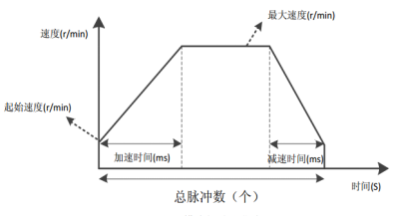
Figure 5.1 Trajectory during normal operation of position mode
Note that in relative positioning mode, the motor's direction is determined by the sign of the total pulse count. Generally, a positive total pulse count indicates forward rotation, while a negative total pulse count indicates reverse rotation. In absolute positioning mode, the motor's initial direction is determined by the sign of the total pulse count, and subsequent directions are also determined by the total pulse count.
If the user-set total pulse count is too low, the motor may need to decelerate before reaching its maximum speed. The speed curve is shown in Figure 5.2. The solid line shows the actual motor trajectory, and the dashed line shows the trajectory required to accelerate to the set maximum speed. The theoretical total pulse count in the figure is the theoretical minimum total pulse count calculated based on the user-set parameters: starting speed, maximum speed, acceleration time, and deceleration time. If the user-set total pulse count is less than the theoretical minimum total pulse count, the motor will operate according to the solid line in Figure 5.2.
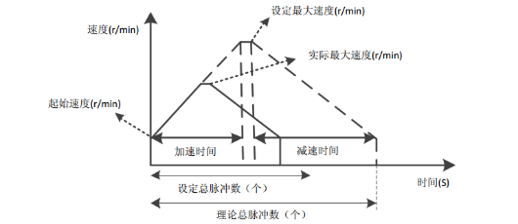
Figure 5.2 Running trajectory when the total number of pulses in position mode is set to be small

5.2 Speed ​​Mode
Speed ​​mode allows the motor to maintain a constant speed at a set speed. Unlike position mode, the user only needs to set the starting speed, maximum speed, acceleration time, and deceleration time. After the motor accelerates to the maximum speed according to the set parameters, it maintains a constant speed. The direction of the motor's rotation is determined by the positive or negative value of the maximum speed. Generally, a positive maximum speed indicates forward rotation, while a negative maximum speed indicates reverse rotation. The acceleration curve for speed mode is shown in Figure 5.3.
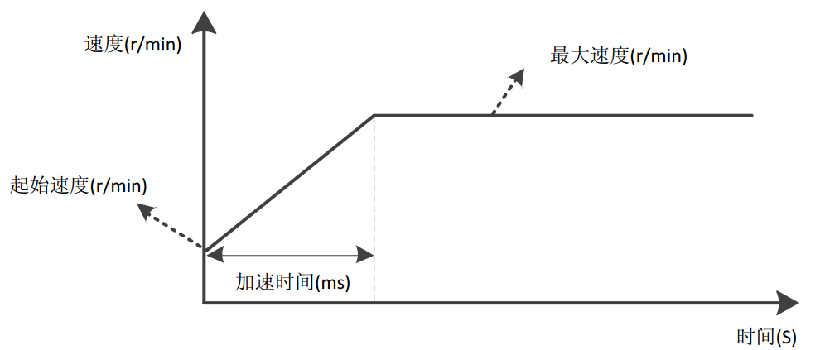
Figure 5.3 Speed ​​mode acceleration curve

5.3 Return to origin mode
The 485 bus type stepper driver currently supports the following return to zero modes: (-3)-(-6), 17-30, 35, 37-39, 41-48. These modes require the use of limit or origin signals.
Before configuring the homing mode, you must first configure the input port function to origin, positive limit, or negative limit. (-3)-(-4) are the stalled-rotor homing methods in closed-loop mode, modes 17-18 are two limit homing methods, modes 19-22 are four origin homing methods, modes 23-26 are four origin + positive limit homing methods, modes 27-30 are four origin + negative limit homing methods, 35 and 37 use the current position as the zero point, 38-39 are position homing modes, and 41-48 are eight dual-photoelectric (origin + positive limit or origin + negative limit) homing methods.
Homing mode can be initiated by sending a 'Start Command' from the host computer or using an external I/O signal as a trigger source. However, an input port must be configured as the 'Homing Enable Signal' function. Prior to this, registers 0x003B to 0x0041 can be used to configure the homing mode, homing speed, homing acceleration/deceleration times, and homing compensation value. The user must select the appropriate homing mode based on the application. The following sections briefly describe the paths used in various homing modes.
Icon explanation: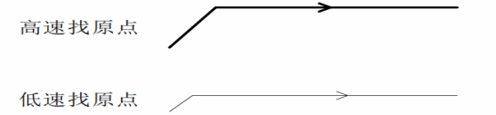
Note:In the following diagrams defining all return-to-zero methods, movement to the right is considered positive movement, and movement to the left is considered negative movement.

5.3.1 Mode (-3) (Stalled Rotor Return to Zero 1)
The motor initially runs in the positive direction at the 'home speed V1'. After a stall occurs, it decelerates to a stop and moves in the reverse direction. After the dynamic torque of the motor disappears, it decelerates to a stop and uses this position as the origin.
The entire process of this zero return method is shown in the figure below. No detailed description is given here.
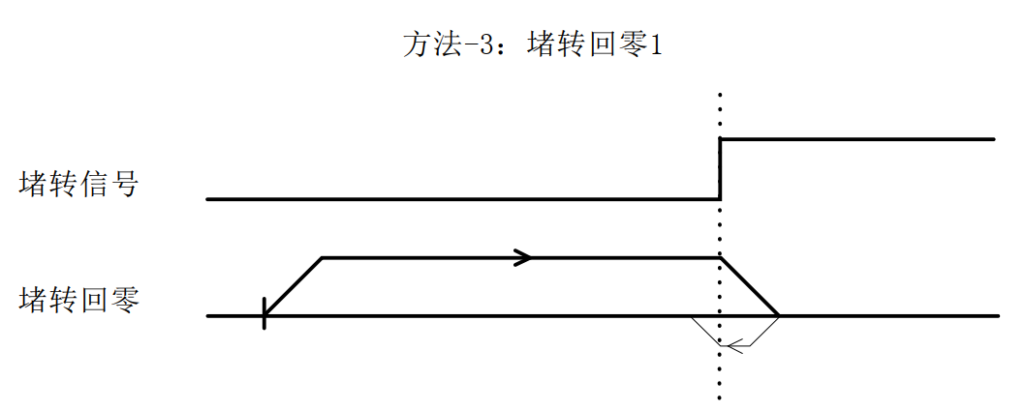

5.3.2 Mode (-4) (Stalled Rotor Return to Zero 2)
The motor initially runs in the reverse direction at the 'home speed V1'. After a stall occurs, it decelerates to a stop and moves in the reverse direction. After the dynamic torque of the motor disappears, it decelerates to a stop and uses this position as the origin.
The entire process of this zero return method is shown in the figure below. No detailed description is given here.
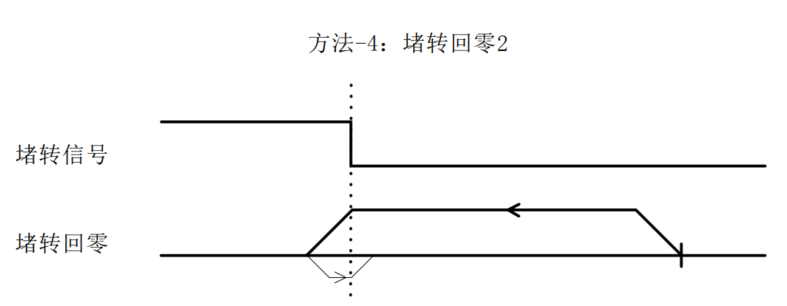

5.3.3 Mode (-5) (Stalled Rotor Return to Zero 3)
The motor initially runs in the positive direction at the 'home speed V1'. When a stall occurs, it stops immediately and the position is used as the origin.
The entire process of this zero return method is shown in the figure below. No detailed description is given here.
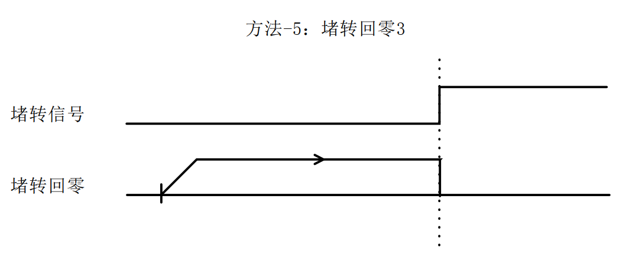

5.3.4 Mode (-6) (Stalled Rotor Return to Zero 4)
The motor initially runs in the reverse direction at the 'home speed V1'. When a stall occurs, it stops immediately and the position is used as the origin.
The entire process of this zero return method is shown in the figure below. No detailed description is given here.
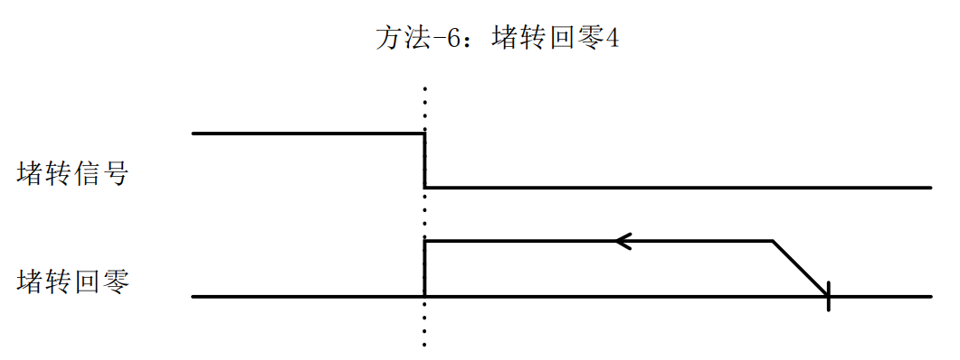

5.3.5 Mode 17 (Negative Limit Return to Zero)
The origin stop position of 'Negative limit return to zero' is at the negative limit signal.
The entire action of 'Negative limit return to zero' is divided into two cases, as follows:
Case A: After receiving the 'Home Enable Signal' command, the drive begins motion at the 'Home Speed ​​V1' and 'Home Acceleration/Deceleration Time' parameters. When it encounters the rising edge of the limit signal, it decelerates to a stop. It then moves in the opposite direction at 'Home Speed ​​V2' until it encounters the falling edge of the limit signal, at which point it decelerates to a stop, completing the home return motion.
Case B: After receiving the 'Home Enable Signal' command, the drive is within the limit. It will start moving according to the 'Home Speed ​​V2' and 'Home Acceleration/Deceleration Time' parameters. When it encounters the falling edge of the limit signal, it decelerates and stops, and the entire home return action is completed.
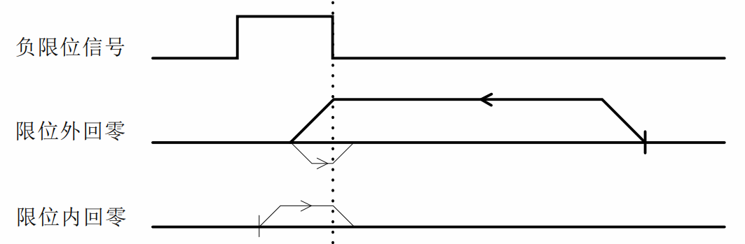

5.3.6 Mode 18 (Positive limit return to zero)
The origin stop position of 'positive limit return to zero' is at the positive limit signal.
'Positive limit return to zero' is similar to 'Negative limit return to zero', except that the running direction is opposite, so it will not be explained in detail here.
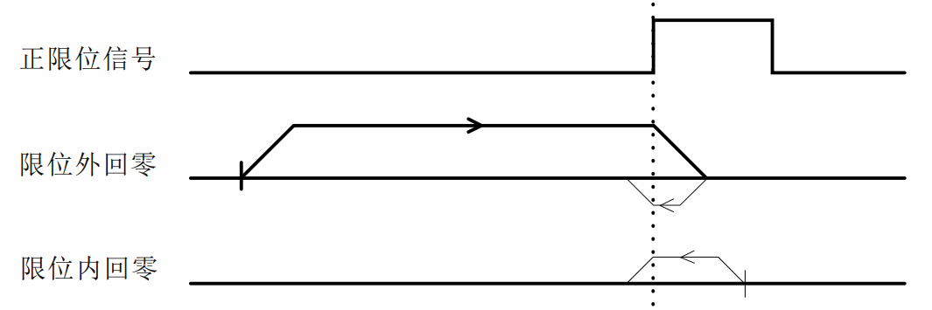

5.3.7 Mode 19 (Home Return 1)
The origin stop position of 'Home Return 1' is on the left side of the rising edge of the origin signal in the positive direction.
The whole action of 'origin return 1' is divided into two cases, as follows:
Case A: After receiving the 'Home Enable Signal' command, the drive moves in the forward direction at the 'Home Speed ​​V1' and 'Home Acceleration/Deceleration Time' parameters. When it encounters the rising edge of the origin signal, it decelerates and stops. It then moves in the reverse direction at the 'Home Speed ​​V2' until it encounters the falling edge of the origin signal, at which point it decelerates and stops, completing the home return operation.
Case B: After receiving the 'Home Enable Signal' command, the drive is within the origin signal. It will move in the opposite direction according to the 'Home Speed ​​V2' and 'Home Acceleration/Deceleration Time' parameters. When it encounters the falling edge of the origin signal, it decelerates and stops, and the entire home return action is completed.
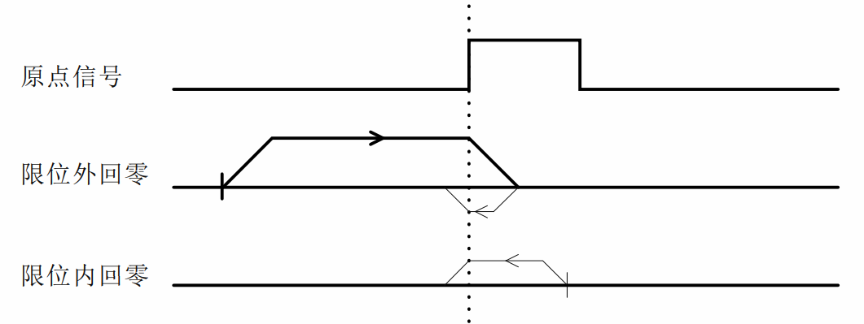

5.3.8 Mode 20 (Home Return 2)
The origin stop position of 'Home Return 2' is to the right of the rising edge of the origin signal in the positive direction.
The entire process of 'Home Return 2' is shown in the figure below. Detailed description is omitted here.
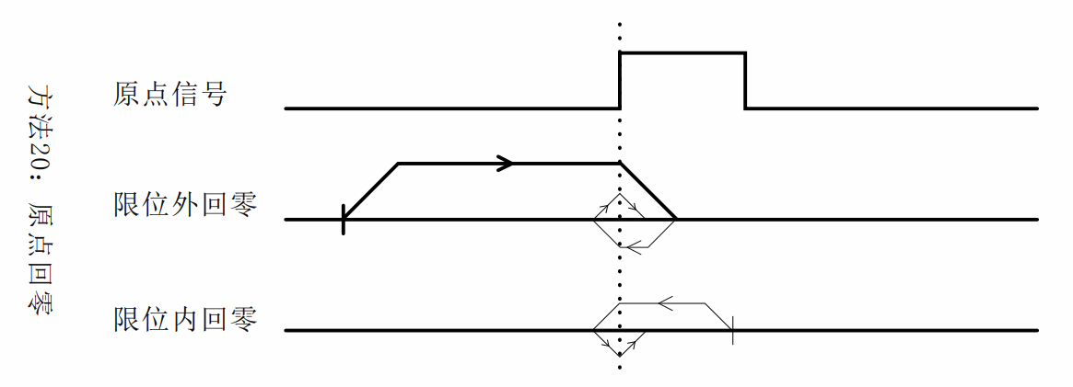

5.3.9 Method 21 (Home Return 3)
The origin stop position of 'Home Return 3' is to the right of the rising edge of the origin signal in the reverse direction.
The entire operation of 'Home Return 3' is similar to 'Home Return 1', except that the initial running direction is opposite. Detailed description is not given here.
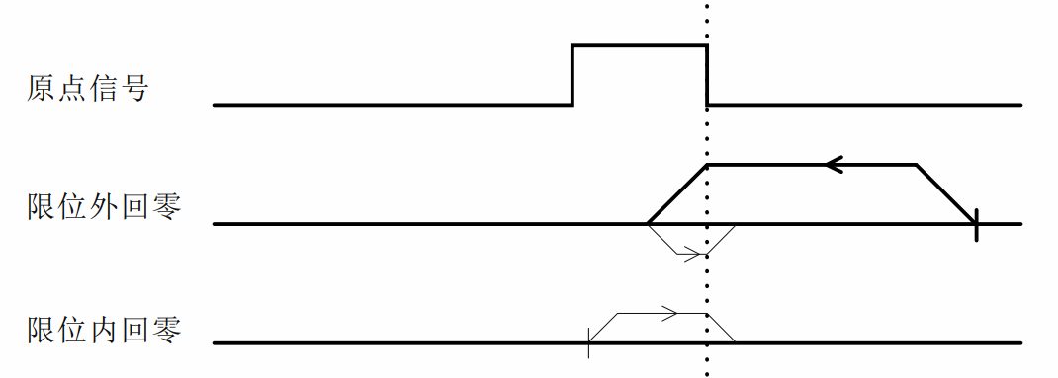

5.3.10 Mode 22 (Home Return 4)
The origin stop position of 'Home Return 4' is on the left side of the rising edge of the origin signal in the reverse direction.
The entire operation of 'Home Return 4' is similar to 'Home Return 2', except that the initial running direction is opposite. Detailed description is not given here.
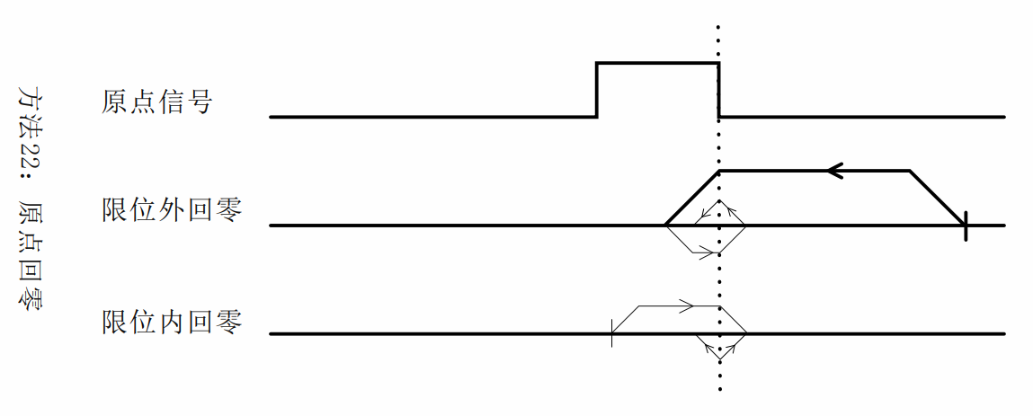

5.3.11 Mode 23 (origin + positive limit return to zero 1)
The origin stop position of 'Origin + Positive Limit Return to Zero 1' is on the left side of the rising edge of the origin signal in the positive direction.
The entire action of 'origin + positive limit return to zero 1' is divided into three cases, as follows:
Case A: After receiving the 'Home Enable Signal' command, the drive moves in the forward direction at the 'Home Speed ​​V1' and 'Home Acceleration/Deceleration Time' parameters. When it encounters the rising edge of the origin signal, it decelerates and stops. It then moves in the reverse direction at the 'Home Speed ​​V2' until it encounters the falling edge of the origin signal, at which point it decelerates and stops, completing the home return operation.
Case B: After receiving the 'Home Enable Signal' command, the drive moves in the positive direction at the 'Home Speed ​​V1' and 'Home Acceleration/Deceleration Time' parameters. It stops immediately when it encounters the rising edge of the positive limit signal. It then moves in the reverse direction at the 'Home Speed ​​V2' until it encounters the falling edge of the home signal, decelerating to a stop. The entire home return process is complete.
Case C: After receiving the 'Home Enable Signal' command, the drive is in the home signal. It will move in the opposite direction according to the 'Home Speed ​​V2' and 'Home Acceleration/Deceleration Time' parameters. When it encounters the falling edge of the home signal, it decelerates and stops, and the entire home return action is completed.
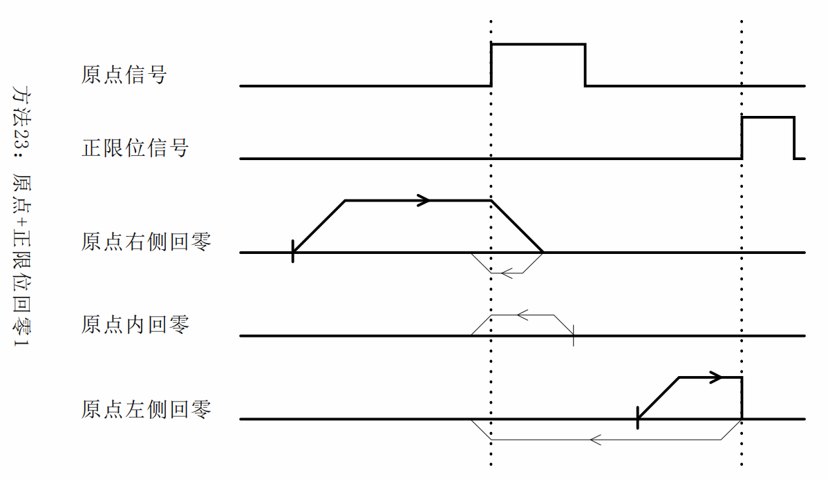

5.3.12 Mode 24 (origin + positive limit return to zero 2)
The origin stop position of 'Origin + Positive Limit Return to Zero 2' is to the right of the rising edge of the origin signal in the positive direction.
The entire operation of 'origin + positive limit return to zero 2' is shown in the figure below. Detailed explanation is omitted here.
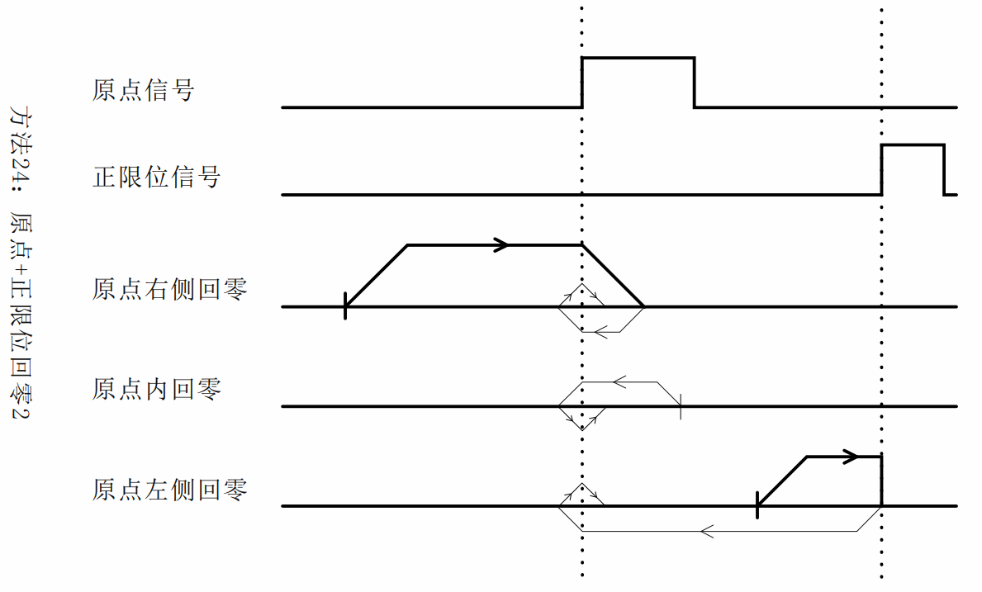

5.3.13 Mode 25 (origin + positive limit return to zero 3)
The origin stop position of 'Origin + Positive Limit Return to Zero 3' is on the left side of the falling edge of the origin signal in the positive direction.
The entire action of 'origin + positive limit return to zero 1' is divided into three cases, as follows:
Case A: After receiving the 'Home Enable Signal' command, the drive moves in the forward direction at the 'Home Speed ​​V1' and 'Home Acceleration/Deceleration Time' parameters. When the Home Signal rises, the drive continues to move. When the Home Signal falls, the drive decelerates and stops. It then moves in the reverse direction at the 'Home Speed ​​V2' until the Home Signal rises, at which point the drive decelerates and stops, completing the return to zero motion.
Case B: After receiving the 'Home Enable Signal' command, the drive moves in the positive direction at the 'Home Speed ​​V1' and 'Home Acceleration/Deceleration Time' parameters. It stops immediately when it encounters the rising edge of the positive limit signal. It then moves in the reverse direction at the 'Home Speed ​​V2' until it encounters the rising edge of the home signal, decelerating to a stop. The entire home return process is complete.
Case C: After receiving the 'Home Enable Signal' command and being within the origin signal, the drive will move in the forward direction at the 'Home Speed ​​V1' and 'Home Acceleration/Deceleration Time' parameters. It will decelerate and stop when it encounters the falling edge of the origin signal. It will then move in the reverse direction at the 'Home Speed ​​V2' until it encounters the rising edge of the origin signal, at which point it will decelerate and stop, completing the return to zero motion.
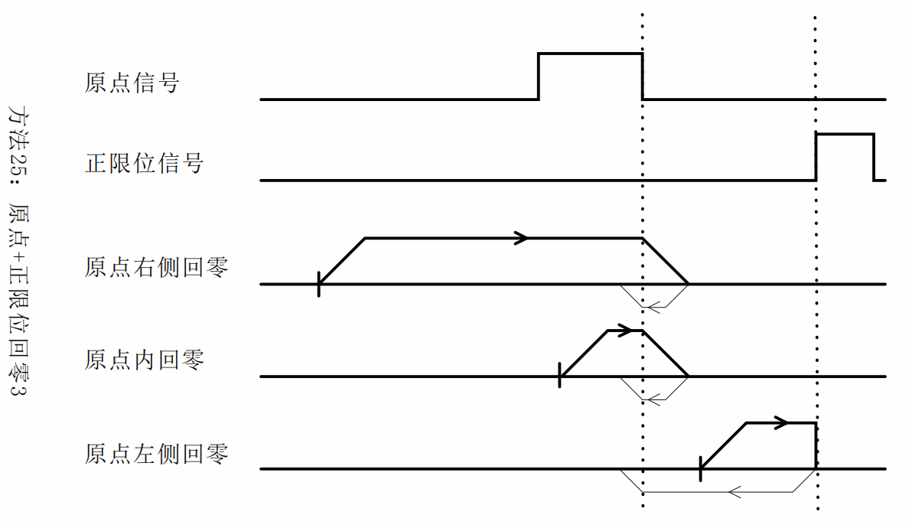

5.3.14 Mode 26 (origin + positive limit return to zero 4)
The origin stop position of 'Origin + Positive Limit Return to Zero 4' is to the right of the falling edge of the origin signal in the positive direction.
The entire operation of 'origin + positive limit return to zero 4' is shown in the figure below. Detailed explanation is omitted here.
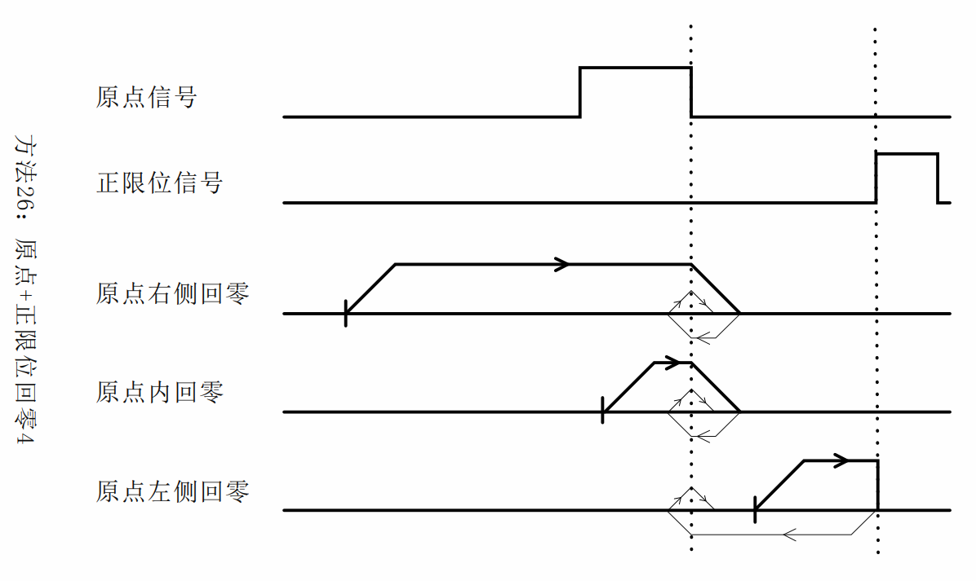

5.3.15 Mode 27 (origin + negative limit return to zero 1)
The origin stop position of 'origin + negative limit return to zero 1' is to the right of the rising edge of the origin signal in the opposite direction.
The entire operation of 'Origin + Negative Limit Return to Zero 1' is similar to 'Origin + Positive Limit Return to Zero 1', except that the initial running direction is opposite. Detailed explanation is not given here.
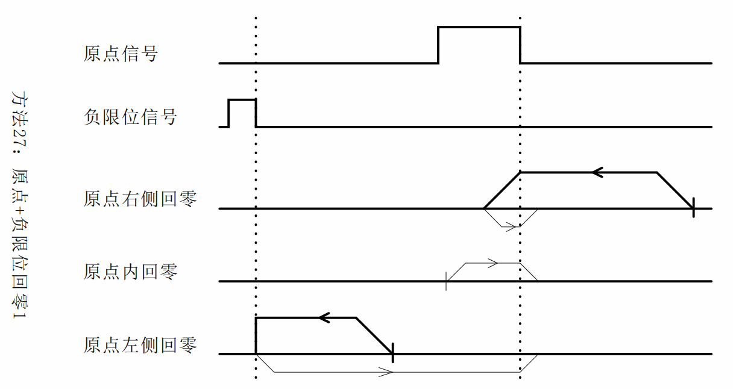

5.3.16 Mode 28 (origin + negative limit return to zero 2)
The origin stop position of 'origin + negative limit return to zero 2' is on the left side of the rising edge of the origin signal in the opposite direction.
The entire operation of 'Origin + Negative Limit Return to Zero 2' is similar to 'Origin + Positive Limit Return to Zero 2', except that the initial running direction is opposite. Detailed explanation is not given here.
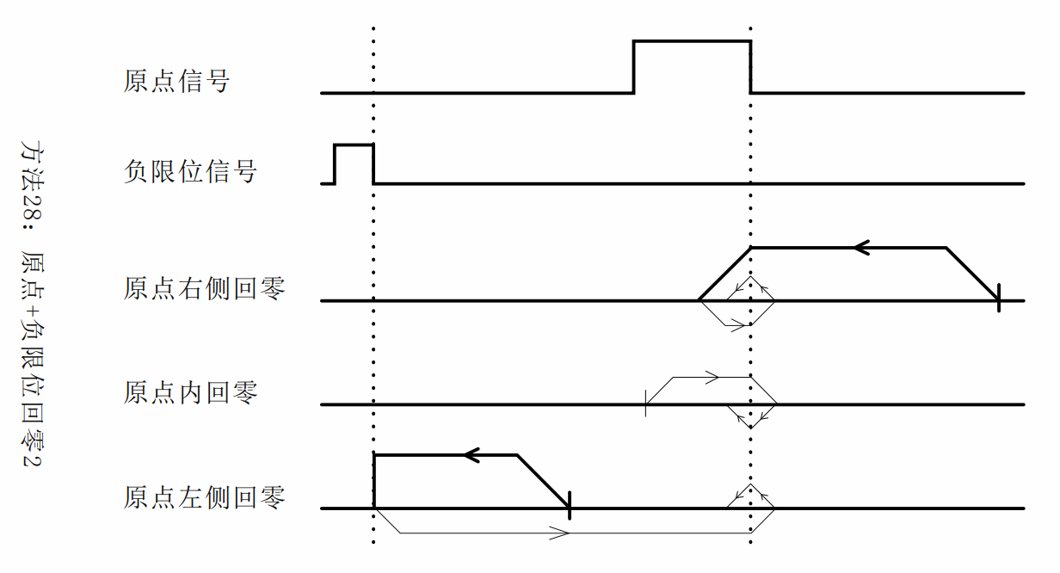

5.3.17 Mode 29 (origin + negative limit return to zero 3)
The origin stop position of 'origin + negative limit return to zero 3' is to the right of the falling edge of the origin signal in the opposite direction.
The entire operation of 'Origin + Negative Limit Return to Zero 3' is similar to 'Origin + Positive Limit Return to Zero 3', except that the initial running direction is opposite. Detailed explanation is not given here.
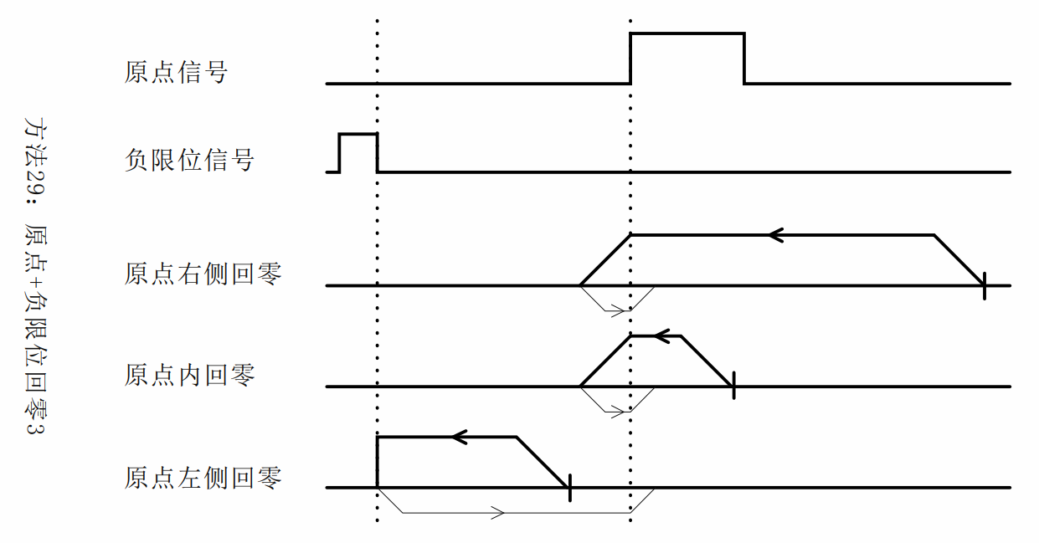

5.3.18 Mode 30 (origin + negative limit return to zero 4)
The origin stop position of 'origin + negative limit return to zero 4' is on the left side of the falling edge of the origin signal in the opposite direction.
The entire operation of 'Origin + Negative Limit Return to Zero 4' is similar to 'Origin + Positive Limit Return to Zero 4', except that the initial running direction is opposite. Detailed explanation is not given here.
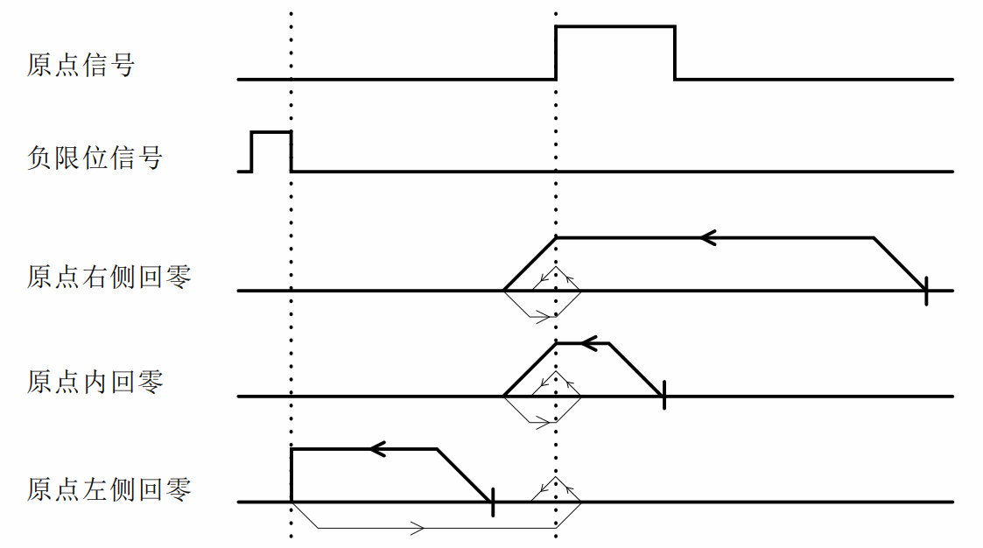

5.3.19 Mode 33 (Z signal return to zero 1)
This zero return method uses the Z signal as the zero return detection signal, which is consistent with the direction of 'negative limit zero return'. The origin stop position is to the right of the Z signal.
The entire process of 'Z signal return to zero 1' is shown in the figure below. Detailed description is omitted here.
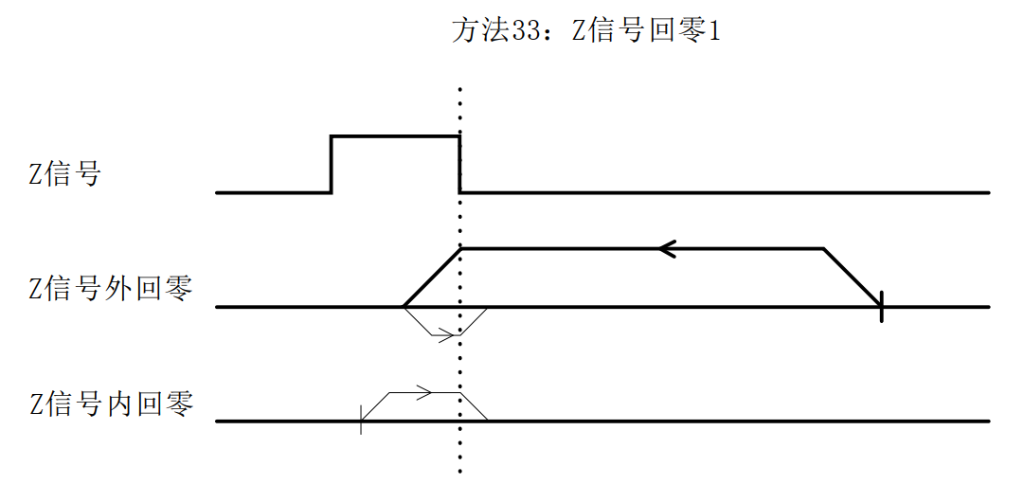

5.3.20 Mode 34 (Z signal return to zero 2)
This zero return method uses the Z signal as the zero return detection signal, which is consistent with the direction of the 'positive limit zero return'. The origin stop position is on the left side of the Z signal.
The entire process of 'Z signal return to zero 2' is shown in the figure below. Detailed description is omitted here.
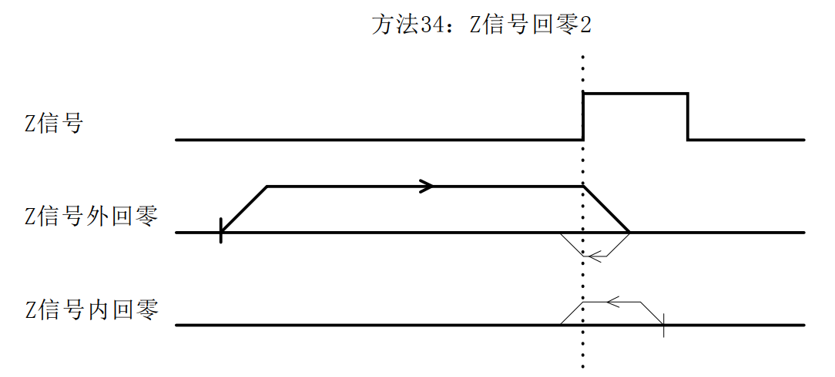

5.3.21 Methods 35 and 37 (Current Position as Origin)
This zero return method uses the current point as the origin.

5.3.22 Mode 38 (Position return to zero mode 1)
This zero return method is consistent with the negative limit zero return direction. When the operation reaches the set position, it stops immediately and takes this position as the origin.
The position value is set through registers 0x0044 and 0x0045;

5.3.23 Mode 39 (Position return to zero mode 2)
This zero return method is consistent with the positive limit zero return direction. When the operation reaches the set position, it stops immediately and takes this position as the origin.
The position value is set through registers 0x0044 and 0x0045;

5.3.24 Mode 41 (Dual Photoelectric Zero Return 1: Origin + Positive Limit)
The origin stop position of 'Dual Photoelectric Return to Zero 1' is on the left side of the rising edge of the two photoelectric signals in the positive direction.
The entire operation of 'Dual Photoelectric Zero Return 1' is divided into two cases, as follows:
Case A: After receiving the 'Home Enable Signal' command, the drive moves in the forward direction at the 'Home Speed ​​V1' and 'Home Acceleration/Deceleration Time' parameters. When it encounters the rising edge of the two photoelectric signals, it decelerates and stops. It then moves in the reverse direction at 'Home Speed ​​V2' until it encounters the falling edge of the two photoelectric signals, at which point it decelerates and stops, completing the home return operation.
Case B: After the drive receives the 'Home Enable Signal' command, it is within the range of two photoelectric signals, or only within one of the photoelectric signals. It will move in the opposite direction according to the 'Home Speed ​​V2' and 'Home Acceleration/Deceleration Time' parameters. When it encounters the falling edge of the two photoelectric signals, it decelerates and stops, and the entire home return action is completed.
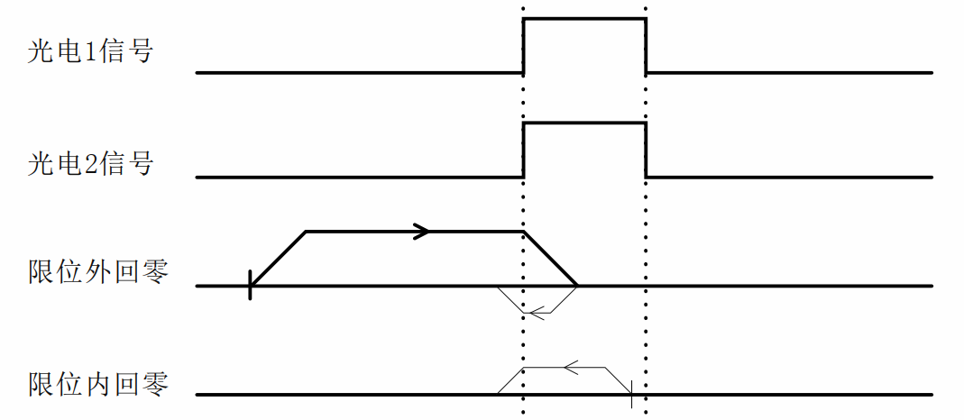

5.3.25 Mode 42 (Dual Photoelectric Zero Return 2: Origin + Positive Limit)
The origin stop position of 'Dual Photoelectric Return to Zero 2' is to the right of the rising edge of the two photoelectric signals in the positive direction.
The entire operation of 'Dual Photoelectric Zero Return 2' is shown in the figure below and will not be explained in detail here.
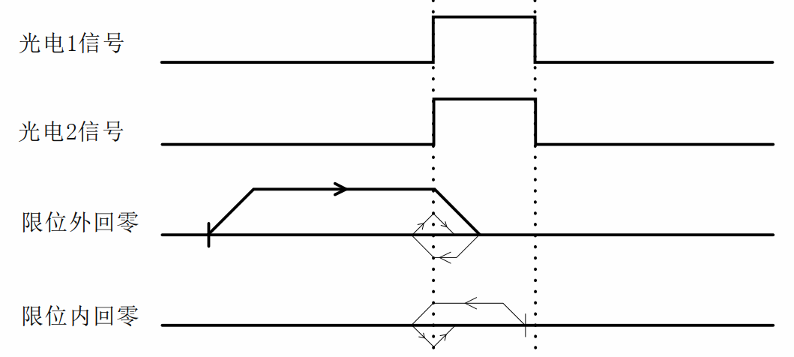

5.3.26 Mode 43 (Dual Photoelectric Zero Return 3: Origin + Positive Limit)
The origin stop position of 'Dual Photoelectric Return to Zero 3' is on the left side of the falling edge of the two photoelectric signals in the positive direction.
The entire operation of 'Dual Photoelectric Zero Return 3' is shown in the figure below and will not be explained in detail here.
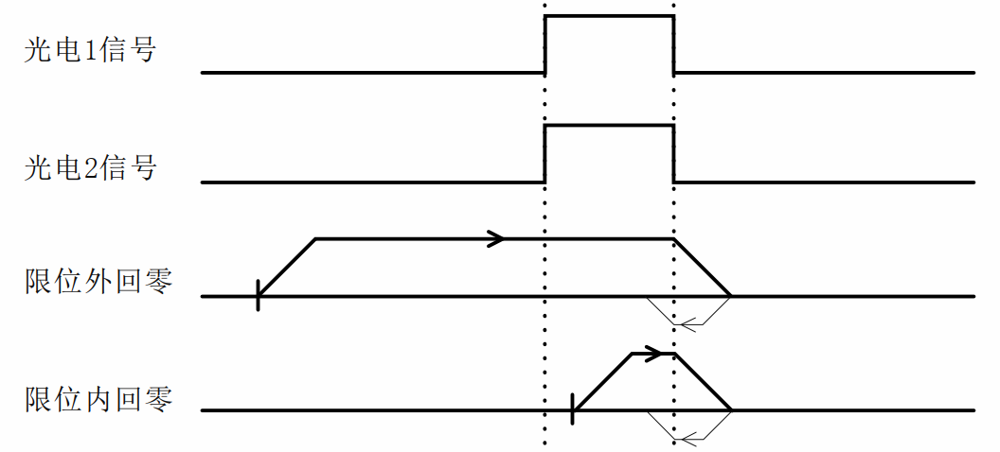

5.3.27 Mode 44 (Dual Photoelectric Zero Return 4: Origin + Positive Limit)
The origin stop position of 'Dual Photoelectric Return to Zero 4' is to the right of the falling edge of the two photoelectric signals in the positive direction.
The entire operation of 'Dual Photoelectric Zero Return 4' is shown in the figure below and will not be explained in detail here.
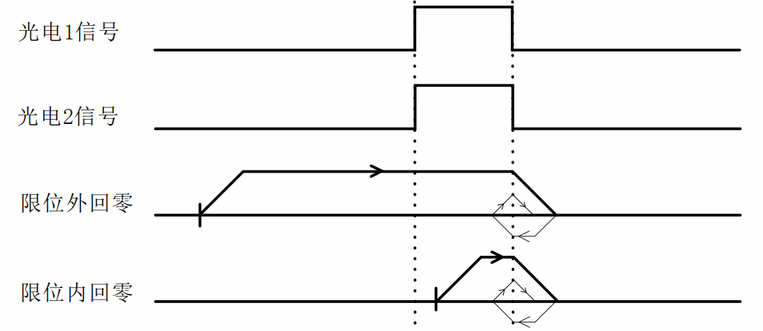

5.3.28 Mode 45 (Dual Photoelectric Zero Return 5: Origin + Negative Limit)
The origin stop position of 'Dual Photoelectric Return to Zero 5' is on the right side of the rising edge of the two photoelectric signals in the opposite direction.
The entire operation of 'Dual Photoelectric Return to Zero 5' is similar to that of 'Dual Photoelectric Return to Zero 1', except that the initial running direction is opposite.
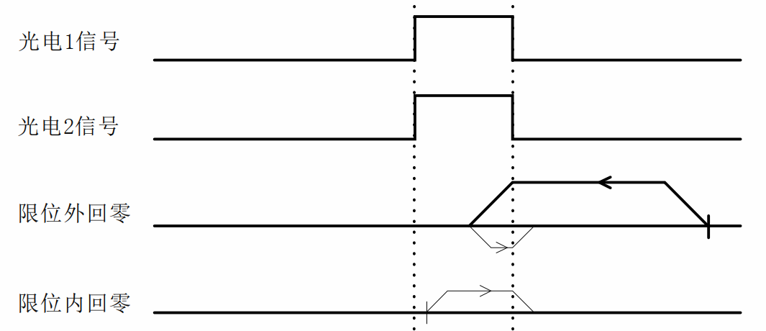

5.3.29 Mode 46 (Dual Photoelectric Zero Return 6: Origin + Negative Limit)
The origin stop position of 'Dual Photoelectric Return to Zero 6' is on the left side of the rising edge of the two photoelectric signals in the opposite direction.
The entire operation of 'Dual Photoelectric Return to Zero 6' is similar to that of 'Dual Photoelectric Return to Zero 2', except that the initial running direction is opposite.
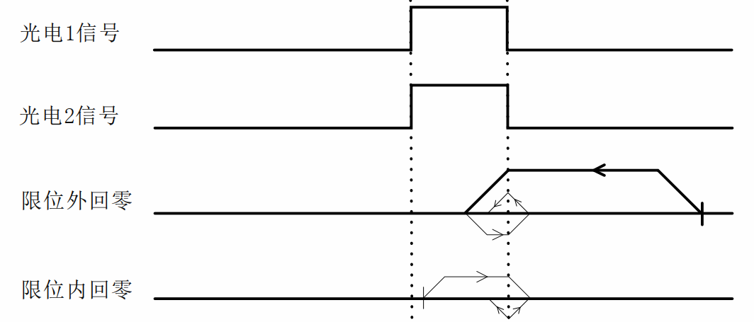

5.3.30 Mode 47 (Dual Photoelectric Zero Return 7: Origin + Negative Limit)
The origin stop position of 'Dual Photoelectric Return to Zero 7' is on the right side of the falling edge of the two photoelectric signals in the opposite direction.
The entire operation of 'Dual Photoelectric Return to Zero 7' is similar to that of 'Dual Photoelectric Return to Zero 3', except that the initial running direction is opposite.
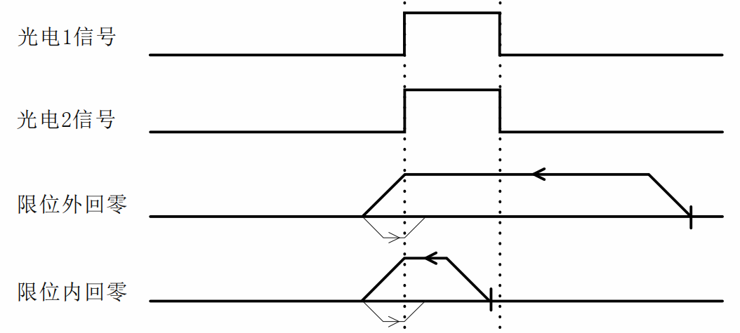

5.3.31 Mode 48 (Dual Photoelectric Zero Return 8: Origin + Negative Limit)
The origin stop position of 'Dual Photoelectric Return to Zero 8' is on the left side of the falling edge of the two photoelectric signals in the opposite direction.
The entire operation of 'Dual Photoelectric Return to Zero 8' is similar to that of 'Dual Photoelectric Return to Zero 4', except that the initial running direction is opposite.
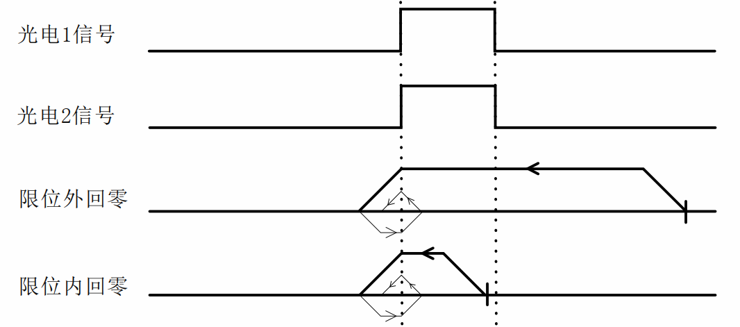

5.4 Multi-segment mode
The multi-segment mode includes multi-segment position mode and multi-segment speed mode, and the register range involved is 0x0060~0x015F.

5.4.1 Multi-position mode
The multi-segment position mode combines multiple position segments and starts the motor according to their path IO numbers (PTIN0 to PTIN3) and external IO trigger signals (TRIG, which can also be set to not require this trigger signal) to complete a series of position actions.
The multi-segment position mode function setting mainly uses two registers (taking path 0 as an example), as shown in the following table:
Register Name | Included Features
Path 0 function setting 1 | - Position/velocity mode;  - Relative/absolute position selection;  - IO in place output signal is prohibited;  - Whether to jump;  - Jump path number;
Path 0 function setting 2 | - Whether homing is enabled;  - Whether to execute the path after returning to the origin;  - Selection of parameters such as the speed of returning to the origin;  - Return to origin method;
By configuring the function registers of the corresponding paths, various position control modes can be achieved, such as IO trigger + path IO mode, IO trigger single cycle mode, IO trigger continuous cycle mode, etc. Users can configure them according to different needs. The following is a brief introduction to the three commonly used modes.

5.4.1.1 IO Trigger + Path IO Mode
The IO trigger + path IO mode means that the execution of each position segment requires the path IO number (PTIN0~PTIN3) and the external IO trigger signal (TRIG) to start the motor. The execution diagram is shown below.
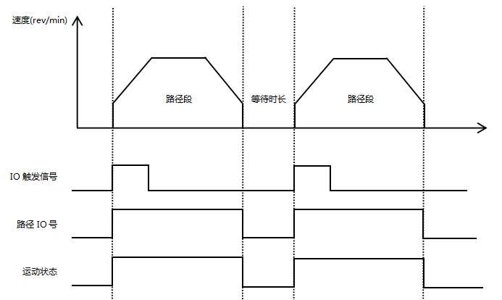
Figure 5.4 IO trigger + path IO mode operation diagram
Note: The path jump function cannot be enabled in this mode, and the IO trigger signal for the next path can only be given after the waiting time is over!
If a path needs to return to the origin before executing it, you need to configure the function of the register 'Path Function Setting 2', turn on the return to origin enable bit, select parameters such as the return to origin speed, whether to execute the path after returning to the origin, and the corresponding return to origin method. The execution diagram is shown below.
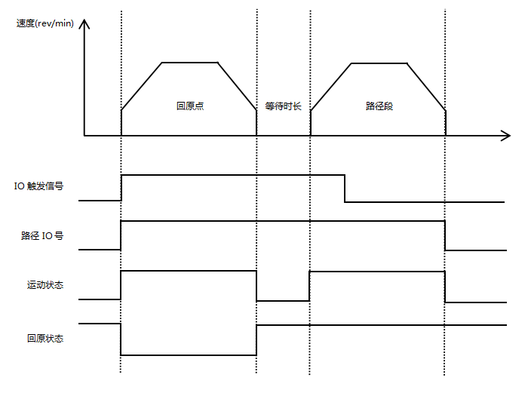
Figure 5.5 Schematic diagram of homing + IO triggering + path IO mode operation
The path IO combination can currently use up to 4 IO ports. By setting whether the IO trigger function is valid, it can support the activation of 16 positions. The combination logic is shown in the following table.
IO port/run path segment | PTIN0 | PTIN1 | PTIN2 | PTIN3 | Path IO  Combined Value | IO trigger signal (TRIG)
Path segment 0 | 0 | 0 | 0 | 0 | 0 | 1 (bootable)
Path segment 1 | 1 | 0 | 0 | 0 | 1 | 1 (bootable)
Path segment 2 | 0 | 1 | 0 | 0 | 2 | 1 (bootable)
Path segment 3 | 1 | 1 | 0 | 0 | 3 | 1 (bootable)
Path segment 4 | 0 | 0 | 1 | 0 | 4 | 1 (bootable)
Path segment 5 | 1 | 0 | 1 | 0 | 5 | 1 (bootable)
Path segment 6 | 0 | 1 | 1 | 0 | 6 | 1 (bootable)
Path segment 7 | 1 | 1 | 1 | 0 | 7 | 1 (bootable)
Path segment 8 | 0 | 0 | 0 | 1 | 8 | 1 (bootable)
Path segment 9 | 1 | 0 | 0 | 1 | 9 | 1 (bootable)
Path segment 10 | 0 | 1 | 0 | 1 | 10 | 1 (bootable)
Path segment 11 | 1 | 1 | 0 | 1 | 11 | 1 (bootable)
Path segment 12 | 0 | 0 | 1 | 1 | 12 | 1 (bootable)
Path segment 13 | 1 | 0 | 1 | 1 | 13 | 1 (bootable)
Path segment 14 | 0 | 1 | 1 | 1 | 14 | 1 (bootable)
Path segment 15 | 1 | 1 | 1 | 1 | 15 | 1 (bootable)

5.4.1.2 IO trigger single cycle mode
IO trigger single loop mode means that after the jump function is enabled (IO trigger function is enabled) for each path, each time the external IO trigger signal (TRIG) starts the motor, a full loop is executed. To execute a second loop, the external IO trigger signal (TRIG) must be triggered again. The execution diagram is shown below.
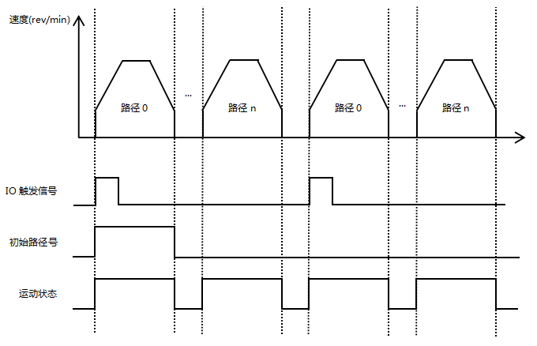
Figure 5.6 IO trigger single cycle mode operation diagram
Note: This mode requires the path jump function to be turned on, but the path jump function must be turned off for the last path segment!
If a path needs to return to the origin before executing it, you need to configure the function of the register 'Path Function Setting 2', turn on the return to origin enable bit, select parameters such as the return to origin speed, whether to execute the path after returning to the origin, and the corresponding return to origin method. The execution trajectory of each path is similar to Figure 5.7 and will not be explained here.

5.4.1.3 IO trigger continuous loop mode
IO trigger continuous loop mode means that after the jump function is enabled (IO trigger function is valid) for each path segment, when the external IO trigger signal (TRIG) starts the motor, the pre-set position segment can be cyclically executed. The execution diagram is shown below.
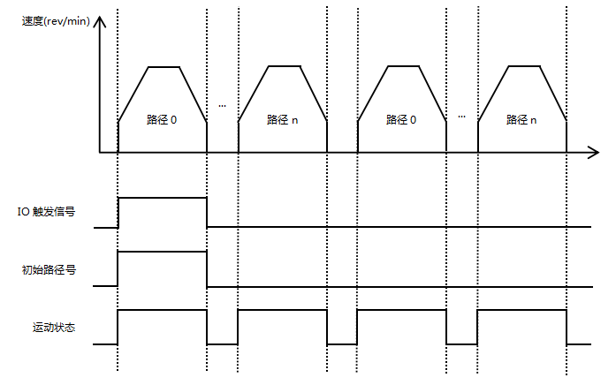
Figure 5.7 IO trigger continuous loop mode operation diagram
Note: This mode requires the path jump function to be enabled, and the jump path of the last path segment n must be set to the initial path!
If a path needs to return to the origin before executing it, you need to configure the function of the register 'Path Function Setting 2', turn on the return to origin enable bit, select parameters such as the return to origin speed, whether to execute the path after returning to the origin, and the corresponding return to origin method. The execution trajectory of each path is similar to Figure 5.7 and will not be explained here.

5.4.2 Multi-speed mode
The multi-speed mode combines multiple speed segments and starts the motor according to the path IO number (PTIN0~PTIN3) and the external IO trigger signal (TRIG) to complete a series of speed operations.
The multi-speed mode function setting mainly uses two registers (taking path 0 as an example), as shown in the following table:
Register Name | Included Features
Path 0 function setting 1 | - Position/velocity mode;  - Relative/absolute position selection;  - IO in place output signal is prohibited;  - Whether to jump;  - Jump path number;
Path 0 function setting 2 | (1) Whether homing is enabled;  (2) Whether to execute the path after returning to the origin;  (3) Selection of parameters such as the speed of returning to the origin;  (4) Return to origin method;
By configuring the function register of the corresponding path, the corresponding path can be configured to run in speed mode. Before executing speed mode, you can also perform actions such as returning to the origin. However, please note that the jump function is not supported in multi-speed mode. The execution diagram is shown below.
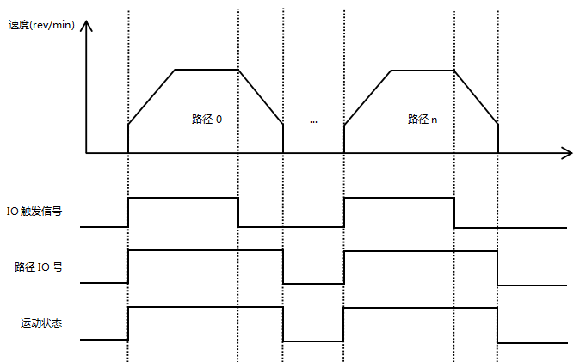
Figure 5.8 IO trigger + path IO mode operation diagram
If a path at a certain speed requires returning to the origin first, you need to configure the register 'Path Function Setting 2' function, turn on the return to origin enable bit, select parameters such as the return to origin speed, whether to execute the path after returning to the origin, and the corresponding return to origin method. The execution trajectory of each path is similar to Figure 5.7.

5.5 Motion Control Instructions

5.5.1 Startup Command
The start command address is 0x0037. Its functions include speed mode trigger, relative position mode trigger, absolute position mode trigger, and homing mode trigger. The function definitions of each bit are shown in the following table:
register | Bit15 | Bit14 | Bit13 | Bit12 | Bit11 | Bit10 | Bit9 | Bit8
0x0037  Startup Command | reserve | reserve | reserve | reserve | reserve | reserve | reserve | reserve
0x0037  Startup Command | Bit7 | Bit6 | Bit5 | Bit4 | Bit3 | Bit2 | Bit1 | Bit0
0x0037  Startup Command | JOG-  sports | JOG+  sports | Multi-speed trigger | Multi-segment position trigger | Return to origin  trigger | Absolute position trigger | Relative position trigger | Speed ​​mode trigger
The following is an example of the settings:
Speed ​​mode motion: 01 06 00 37 00 01 F9 C4
Relative position movement: 01 06 00 37 00 02 B9 C5
Absolute position movement: 01 06 00 37 00 04 39 C7

5.5.2 Stop Command
The stop command address is 0x0038, and its functions include normal stop, emergency stop, continuous operation at the set speed, or operation along the planned trajectory until stopping.When the motor is running in position mode or speed mode, if it receives a normal stop command, the motor will decelerate and stop according to the set deceleration time, and if it receives an emergency stop command, it will stop directly. The setting value range is 0~2.The function definitions of each setting value are shown in the following table:
register | illustrate
0x0038  Stop Command | 0: normal stop;  1: Emergency stop;  2: Run at the set speed or along the planned trajectory until it stops;
The following is an example of the settings:
Normal stop: 01 06 00 38 00 01 C9 C7
Emergency stop: 01 06 00 38 00 02 89 C6
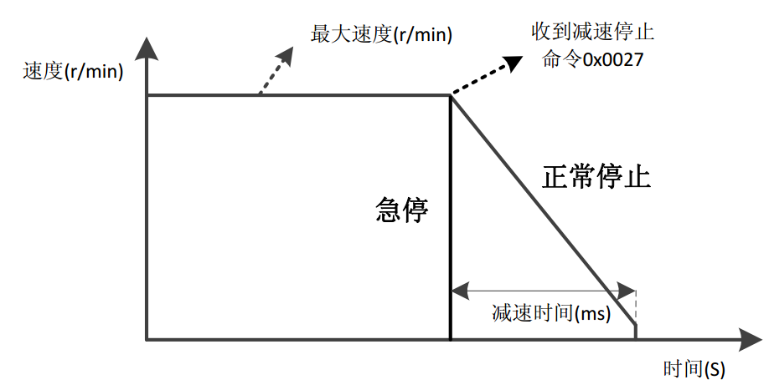
Figure 5.9 Normal stop and emergency stop

6. Indicator Light

6.1 Alarm fault codes
The 485 bus open- and closed-loop stepper driver has a variety of alarm information. When the driver alarms, the fault code and treatment measures are shown in Table 6.1. For details, please refer to the relevant content of Section 4.2.13 Fault Code Parameter Group.
Table 6.1 Fault codes and solutions
Fault Code | Fault subcode | Fault information | indicator light | Treatment measures
0x01 | 0x10: overcurrent; | Overcurrent | Flash | - Check whether the motor wires are connected incorrectly;  - Check whether there is contact between two adjacent wires;  - After troubleshooting, power on again for testing;
0x02 | 0x20: overvoltage alarm;  0x21: Undervoltage alarm; | Overvoltage and undervoltage | Flash | Check the power supply
0x03 | 0x30: Forward hard limit overtravel;  0x31: Reverse hard limit overtravel;  0x32: Forward soft limit overtravel;  0x33: Reverse soft limit overtravel; | Hard limit/soft limit overtravel | none | Move in the opposite direction;
0x04 | 0x41: read error;  0x42: write error; | EEPROM  Read and write errors | none | Resettable
0x05 | 0x51: CRC check error;  0x52: Function code error;  0x53: Error in reading illegal data address;  0x54: The write data address is out of range;  0x55: The number of registers read overflows (a maximum of 16 registers can be read at a time);  0x56: Function code illegal read and write error;  0x57: The data written into the register exceeds the limit; | MODBUS  Communication Error | none | Resettable
0x06 | 0x60: Both phase A and phase B are missing alarm;  0x61: Phase A is missing;  0x62: Phase B is missing; | Phase loss alarm | Flash | - Check whether the motor wiring is loose or connected incorrectly;  - After troubleshooting, power on again for testing;
0x07 | 0x70: Normal out-of-tolerance alarm;  0x71: Overvoltage causes an out-of-tolerance alarm;  0x72: Undervoltage causes an out-of-tolerance alarm; | Out-of-tolerance alarm | Flash | - Check whether the motor wiring is correct;  - Check whether the current setting is sufficient;  - Check whether the power supply is sufficient;  - The alarm can be cleared by enabling the signal;
0x08 | 0x80: Return to origin timeout alarm; | Return to origin  Timeout alarm | Flash | - Check whether the limit is damaged;  - Check whether the limit wiring is loose;  - This alarm can be cleared through the host computer or external IO input function;
0x09 | 0x90: Restore factory settings;  0x91: save status parameter group;  0x92: Save the common parameter group;  0x93: Save the common open-loop parameter group;  0x94: Save the closed-loop common parameter group;  0x95: Save basic control parameter group;  0x96: Save the back-to-origin parameter group;  0x97: Save input and output parameter group;  0x98: Save multi-segment mode parameter group;  0x99: save the performance parameter group;  0x9A: Save the brake parameter group;  0x9B: Save fault code parameter group;  0x9C: Save user parameter group;  0x9D~0x9E: Reserved;  0x9F: Save all parameter groups; | Factory Reset/  Save Parameters | Flash | (1) Wait until the indicator light stops flashing and returns to normal display state before proceeding to the next step;
0x0A | 0xA0: Vmax>Vmin; | Alarm when speed parameter setting is unreasonable | none | Check whether the maximum speed value is less than the minimum speed value;

6.2 Indicator light flashes
The 485 bus open/closed loop stepper driver has a green LED and a red LED. One of them can be used as a power indicator, and the other can be used as a fault indicator, a DIP switch status indicator, or a parameter save or restore indicator. The specific relationship is shown in Table 6.2 below:
When the driver is powered on, the green LED is always on, and when the driver is powered off, the green LED is off.
When a fault occurs in the drive, the red and green lights flash alternately, with different flashing patterns indicating different fault information. When the fault is corrected by the user, the green LED remains on and the red LED goes out.
When saving/restoring parameters, the red and green lights flash alternately. When saving/restoring parameters is completed, the green LED is always on and the red LED is off.
Table 6.2 LED status indication
Number of LED flashes |  | Phenomenon | illustrate
Green LED | Red LED | After the green light flashes, the red light flashes
0 | - | Green light is always on, red light is off | Driver Enable
1 | - | Green light flashes, red light off | The driver is enabled and receives a pulse or start command
1 | 1 |  | Normal out-of-tolerance alarm
2 | 1 |  | The driver is not enabled and receives a pulse or start command
3 | 1 |  | (Overvoltage) out-of-tolerance alarm
4 | 1 |  | (Undervoltage) out-of-tolerance alarm
1 | 4 |  | Overpressure alarm
2 | 4 |  | Undervoltage alarm
1 | 5 |  | Overcurrent alarm
1 | 6 |  | AB phase loss alarm
2 | 6 |  | Only A phase loss alarm
3 | 6 |  | Only B phase loss alarm
1 | 8 |  | Timeout alarm in homing mode
1 | 2 |  | Restoring parameters
2 | 2 |  | Saving parameters in progress

7. Warranty and after-sales

7.1 Warranty

7.1.1 Free warranty
Our company solemnly promises that all our products will be repaired free of charge for one year if they are damaged during use. The shipping costs will be borne by both parties.

7.1.2 Warranty Exclusion
- The driver is damaged due to the customer's own wiring errors;
- The driver is damaged due to exceeding the rated working voltage;
- The DC power supply driver is connected to the AC power supply, causing damage to the driver;
- The driver is damaged due to the customer's on-site environment being extremely harsh, such as humidity, extreme cold, extreme heat, etc., without informing our company in advance;
- The customer has dismantled the drive casing without authorization or the serial number label has been torn off;
- 15 days after the customer confirms receipt, the casing is obviously damaged or impacted, resulting in damage to the drive;
- Force majeure natural disasters, such as fire, earthquake, tsunami, typhoon, etc.;
In the above cases, our company will charge a certain amount of repair cost after evaluating the interests of all parties. In other cases, the repair will be free of charge forever.

7.2 Exchange

7.2.1 Product Replacement for Faulty Products
For any faults that occur in new products, our company provides a three-month free replacement service.
Once our technical support staff confirms that the problem is with the product itself, they will ship the product back to us to avoid wasting time and postage. Customers must first return the faulty product by courier or logistics. Upon receipt, we will promptly ship a replacement product to the customer.
Notice:All our products undergo rigorous testing and aging before leaving the warehouse, so it is extremely rare for new products to malfunction. Please be sure to read the instructions carefully or consult our technical support staff when operating, or our technical support staff will assist customers remotely with operation.
- Please note the following points when exchanging goods:
(1) Please ensure that the package is complete when returning to avoid damage during transportation;
(2) Please ensure that the attached accessories are complete when exchanging the product;
(3) Each driver should be packaged independently in its original outer box to avoid secondary damage to the product during transportation;
(4) If the driver is returned and it is confirmed that the fault is not due to product failure, but is caused by the customer's negligence in operation, which mistakenly believes that the driver is faulty, the company will not bear the shipping fee (the customer's negligence includes: wrong wiring resulting in damage to the driver, poor wiring resulting in the driver being damaged, operating errors resulting in the driver being unable to operate normally, etc.).

7.2.2 Exchange for non-product failure
If you are dissatisfied with the appearance or functionality of the product you received and would like to exchange it for a superior driver, you can request a replacement within one week of receiving the product. After verification, we will return the product and, upon confirmation that the returned product is undamaged, has all accessories, and is well packaged, we will replace it with another product. If there is a price difference between the replacement product and the replacement product, the customer will pay the difference.
Note: The replaced product will no longer be eligible for the non-product fault replacement service. The round-trip shipping costs and other expenses incurred by the non-product fault replacement service are borne by the customer!

7.3 Returns
Our company provides a 7-day return service for products with quality problems. If you find any quality problems with the product itself within 7 days of receiving the product (based on the actual date of receipt by the customer), please communicate with our salesperson or technical support personnel in a timely manner. After our technical support personnel confirms that it is a quality problem with the company's product itself, the customer can send the original complete product and its inner and outer packaging, accessories and shipping order back to our company by express delivery or logistics.
If the customer still insists on returning the goods after our company has checked and confirmed that they are correct, the round-trip shipping costs and all other expenses incurred shall be borne by the customer.
- Please note the following points when returning products:
(1) Please contact the relevant department of our company before making a refund;
(2) The product must be in new condition and intact packaging. Please send it back to our company by express or logistics;
(3) We will not accept any complaints caused by customers, such as product appearance damage, incomplete accessories, etc.

7.4 After-sales Service
If you need after-sales service support when using this product, please contact our company as soon as possible.
National free service hotline: 0755-23206995;
Technical specialist service hotline: 18576758897;
Service hours: Monday to Friday 8:30-17:30 (except national holidays).

8. Version Revision History
Version number | illustrate | Modification deadline | Preparer/Reviewer
V1.0.0 | Initial use version | 2023.6.17 | TCJ/XH
V1.0.1 | - This manual is based on the RSA86E-485 Bus-Type Open-Closed Loop Stepper Driver User Manual V1.1.1. Only the product silkscreen section 3.1 and the current setting section 3.2.4 have been modified. | 2024.01.30 | TCJ/XH

